European Flood Awareness System

EFAS Bulletin

February – March 2021

Issue 2021(2)

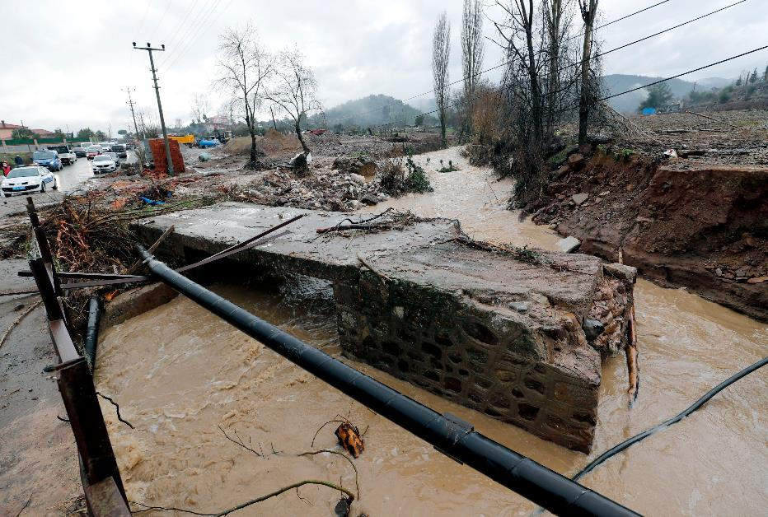

NEWS

New features

New webinar
A new webinar on ‘The Use of EFAS v4.0 for Forecasting’ was published on the EFAS website. This webinar provides information and a short demonstration on how different aspects of the new EFAS v4.0 release can be used for forecasting purposes. This webinar was given as a training session to users of EFAS and was hosted by the Dissemination Centre (DISS) on 10 December 2020.

Problems when submitting feedback?
Have you recently experienced any problems when submitting feedback to EFAS? We are constantly developing the feedback function and appreciate your input if something goes wrong.

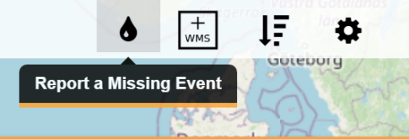
Figure 1: To report a missing event in EFAS - click the icon in the top right corner of the map viewer.
The EFAS operational centres welcome partner feedback on the usefulness and accuracy of EFAS forecasts as its helps us provide a better product and more relevant forecasts to our partners. You can provide feedback on Formal and Flash Flood Notifications directly from the notification e-mail. Additionally, we also encourage you to provide feedback even for missed events using the dedicated function in the EFAS Map Viewer.
The feedback providing function is in constant development and, for this reason, it may sometimes not work as expected. If you encounter any problem when attempting to submit feedback, please let us know by sending an e-mail to info@efas.eu. Your help is greatly appreciated!

New Partners

New EFAS Third Parties
We gladly welcome the World Bank and the Portuguese Environment Agency (Agência Portuguesa do Ambiente) as new EFAS Third party partners.

RESULTS

Summary of EFAS Flood and Flash Flood Notifications

The 20 formal and 20 informal EFAS flood notifications issued in February - March are summarised in Table 1. The locations of all notifications are shown in Figure 23 and Figure 25in the appendix.

641 Flash flood notifications were issued in February - March. They are summarised in Table 2. The locations of all notifications are shown in Figure 24 and Figure 26 in the appendix.

Meteorological situation

by EFAS Meteorological Data Collection Centre

February
February 2021 was characterised by lower than normal mean sea surface pressure over the Atlantic Ocean and from Russia and Kazakhstan southward to the Persian Gulf. Higher than normal mean sea surface pressure occurred from Spitzbergen, Scandinavia, central Europe, and the central Mediterranean region to northern Africa. Monthly precipitation totals were above the long-term means at the Iberian Peninsula, Great Britain and Ireland, eastern Europe, northwest Africa and around the Arabian Peninsula. Below normal monthly precipitation totals were observed in Iceland, southern Scandinavia, the Baltic Sea region, the Alps, at the northern Balkans, and in eastern and southern Mediterranean regions. Monthly mean air temperatures were below the long-term means in the north and east, and above normal in the west and south of the EFAS domain.

In the beginning of February 2021, the Azores High was shifted southward compared to its normal position and disappeared in the next days. A large low-pressure system was located over northeast Europe and the corresponding upper-level trough extended to the central Mediterranean region. Within this trough, a secondary low-pressure zone at the surface extended from the Atlantic Ocean southward of Greenland to France. As the large low-pressure system moved to the Kara Sea, two low-pressure systems developed in the low-pressure zone over the Atlantic Ocean. The upper-level trough weakened, but a flat upper-level low-pressure system was cut-off over the eastern Mediterranean region. Severe weather was reported from many locations in this region at the beginning of February. The low-pressure systems from the Atlantic Ocean moved to Great Britain and Ireland and then continued to central Europe and was associated with large amounts of rain and snowfall. A new low-pressure system developed over the Baltic Sea and moved eastward while intensifying. An upper-level trough extended southward while moving eastward over the Atlantic Ocean, leading to a formation of a low-pressure system at the Iberian Peninsula. The low-pressure system moved eastward to the central Mediterranean region and brought high amounts of rain along its track. Another low-pressure system moved from the Atlantic Ocean via the Adriatic Sea to the Black Sea and a high-pressure system developed over southern Scandinavia. The low-pressure system then changed direction towards the northeast while a strong intensification of this formerly weak system took place. The high amounts of new snow in Russia observed at this time were associated with this system. The high-pressure system moved via central to southeast Europe. Together with low-pressure systems westward of Great Britain and Ireland, which brought also strong winds to Iceland, Great Britain and Ireland, unusual warm air was advected from northern Africa to western and central Europe. At some places in central Europe temperature differences of about 40°C between the maximum temperature in these days and the minimum temperature one week before were observed. During the same days, heavy rain and snow occurred in the eastern Mediterranean region due to a newly developed low-pressure system. Later, a trough swivelled from the Atlantic Ocean to the Iberian Peninsula while getting steeper, cutting-off an upper-level low-pressure system which then moved to northern Africa. A similar event repeated some days later while a high-pressure system developed over the Atlantic Ocean. The high-pressure system moved towards Great Britain and Ireland by the end of February and a low-pressure system shifted its location from northern Scandinavia to Russia. Except for this low-pressure system, the majority of the EFAS domain was influenced by high pressure by the end of February.

In February 2021, the highest precipitation totals were observed at the north-western Iberian Peninsula, Great Britain and Ireland, and eastward of the Adriatic, Aegean and Black Seas (Figure 9). No or almost no precipitation fell in southern Scandinavia, east of the Baltic Sea, at the eastern Balkans, northern Africa and the Levant. Monthly precipitation totals below the long-term means occurred in Iceland, southern Scandinavia, especially east, but almost all around the Baltic Sea, in the Alps, in northern and southern Balkans, northern Levant, the Central Mediterranean region, the southeast Iberian Peninsula and the majority of the African parts of the EFAS domain (Figure 10). Monthly totals above the long-term means were reported at the north-western Iberian Peninsula, in Great Britain and Ireland, eastern Europe, the Arabian Peninsula and northwest Africa.

The monthly mean air temperature ranged from -33.4°C to 20.5°C with the highest values in the southern parts of the EFAS domain. The lowest temperature values were reported in the northern, eastern and mountainous parts (Figure 13). Air temperature anomalies ranged from -11.2°C to 7.4°C (Figure 14). Monthly mean air temperatures below the long-term means occurred in the eastern and northern parts of the EFAS domain while positive temperature anomalies appeared in the west and south of the domain.

March
March 2021 was characterised by higher than normal mean sea surface pressure over the Atlantic Ocean towards central Europe, the Mediterranean Region, and some small areas of Kazakhstan. Lower than normal mean sea surface pressure occurred from Spitzbergen to Scandinavia and northern Russia. Monthly precipitation totals were above the long-term means in Scotland, northern parts of Great Britain, parts of northern Algeria, Morocco, Libya, Egypt, and in neighbouring regions of the Black Sea. Abnormally low monthly precipitation totals were observed in Iceland, Sweden, Finland, central Europe, northern Italy, northern Ukraine up to Russia, the Iberian Peninsula (except the south-eastern coastal areas), around the Caspian Sea, and in the south-eastern regions of the EFAS domain. Monthly mean air temperatures were above the long-term means in most parts of northern Europe as well as in the southeast of the EFAS domain and were below normal in the Balkans, Russia, and in regions around the Black Sea.

At the beginning of March, high-pressure systems dominated the weather situation in most parts of the EFAS domain. Thereby, Scandinavia was influenced by a strong low-pressure system, which extended to Russia and gradually to central Europe. In the meantime, a new low-pressure system developed over the Atlantic moving towards the Iberian Peninsula. This led to heavy rain and caused flash floods in the Andalusia and Murcia regions of southern Spain on March 5. Over the next few days, low pressure increasingly became dominant over Europe, until the high-pressure system over the Atlantic extended to southern Europe. During this time, the low-pressure system over Iceland influenced the weather conditions in northern Europe. In mid-March, a high-pressure system over the Atlantic extended to Scandinavia and shifted the upper low-pressure system over northern Europe to the southeast. The upper-low-pressure system cut off over the Balkans and moved very slowly to the east of the EFAS domain. Also, this low-pressure system displaced the high pressure over most parts of Europe while on the other hand, the high-pressure system over the Atlantic had become slightly stronger. Nevertheless, it was not enough to displace the upper-low-pressure system over Europe. These weather conditions remained stable for several days. Finally, the high pressure dominated and pushed the upper-low-pressure area eastward. A new low-pressure system developed over eastern Europe, which was quite stable. By the end of the month, the low-pressure system over Greenland extended to northern Europe while the rest of the EFAS domain was dominated by high-pressure systems. The high-pressure area strengthened and moved towards Scandinavia. Nevertheless, the strong low-pressure area over Iceland remained. The upper-low-pressure trough over eastern Europe cut off and a low-pressure system developed over the Black Sea. Another low-pressure system developed and merged with this low-pressure system over the Balkans. A ridge of high pressure was located over central and southern Europe. Scandinavia was still influenced by low-pressure systems.

In March 2021, the highest precipitation totals were observed at the coastline of Norway, northern Great Britain, Scotland, Ireland, the Alps, the Strait of Gibraltar, southern Italy, Sicilia, and eastward of the Adriatic, Ionian and Black Seas (Figure 11). No or almost no precipitation fell in Sweden, central Spain, northern Portugal, southern France, northern Italy, southern Slovakia, Hungary, northern Ukraine up to Russia, central Poland, the Caspian Sea, and the Levant. Monthly precipitation totals below the long-term means occurred in Iceland, Sweden, Finland, central Europe, the Iberian Peninsula (except along the south-eastern coastline), northern Italy, northern Ukraine up to north-eastern Russia, around the Caspian Sea, in parts of northern Africa, and the Levant (Figure 12). Monthly totals above the long-term means were reported at the south-eastern Iberian Peninsula, in northern Great Britain and Scotland, around the Black Sea, and in some parts of northern Africa.

The monthly mean air temperature ranged from -18.3°C to 24.3°C with the highest values in the southern parts of the EFAS domain. The lowest temperature values were reported in the northern, eastern, and mountainous parts (Figure 15). Air temperature anomalies ranged from -5.9°C to 8.8°C (Figure 16). Monthly mean air temperatures below the long-term means occurred in eastern Europe, around the Black Sea, and in Russia while positive temperature anomalies appeared in the Middle East, in northern Europe except Iceland, in some parts of northern Italy, Africa, the Pyrenees, northern Portugal, and southern Spain.

Hydrological situation

by EFAS Hydrological Data Collection Centre

February
In February the hydrological situation was very similar to January with abundant rain that caused exceedances in a high number of stations, especially in central Europe. 263 stations registered exceedances in January, but this number increased to 297 in February. The affected basins and countries continue as they were in January. According to the number of stations affected, the Danube basin stands out again with 122 stations having values over their thresholds, which corresponds with the 22% of the stations located in this basin. Countries affected within this basin are southern Germany, Romania, Serbia, Hungary, Bosnia & Herzegovina, Austria, Czech Republic, and Slovenia. Another region with remarkable exceedances was found in the Po river basin, which accounted for 20% of stations located on this basin (31 stations). The Rhine basin stands out in third place with 19% of its stations with exceedances (in Germany and Switzerland). Other affected basins with more dispersed stations are the Oder, Vistula, Elbe, and Dnieper river basins (affecting Poland, Czech Republic, Belarus, and Ukraine) and in Spain along the Minho, Guadiaro, Guadalhorce, and Velez river basins in the Mediterranean and Levante areas. Finally, scattered stations with exceedances appear in Norway, Sweden, and Iceland.

According to stations registering values above the 90% quantile, they are mostly located in central Europe. The Danube basin stands out with nearly 30% of the total stations exceeding the 90% quantile. Other basins registering a high concentration of stations are the Rhine and Elbe basins. To a minor extent in this area, stations also surpassing the 90% quantile are located in the Vistula, Oder, and Dnieper basins. Also, an isolated station on Dniester basin (Ukraine) surpassed the 90% quantile. Other high densities of stations can be found throughout the Spanish basins (Douro, Minho, Limia, Guadalquivir, and Ebro basins) and in the Scandinavian basins (mainly in southern Norway, followed by northern regions of Norway, Sweden and Finland with some scattered stations to the west of Sweden). To a minor extent, stations exceeding the 90% quantile can be observed in Ireland and the UK (all the stations in the Thames basin, England). Scattered stations surpassing the 90% quantile can be seen in France (four stations located in four different basins: Garonne, Rhône, Loire and Orb), two in the Rhone basin (Switzerland), one in the Soca/Isonzo basin (Slovenia), and the Po basin (Italy).

Lastly, regarding the stations registering values below the 10% quantile, the number has been reduced in February in contrast to the previous month. The highest concentration of stations is mainly found in central Norway, with six stations whose mean values are below the 10% quantile. In a more dispersed pattern, we also find a total of seven stations in the Danube basin (Germany and Romania), Dnieper basin (Ukraine), Rhine basin (Germany), Oder basin (Poland), and the Neman basin (Belarus). Finally, an isolated station also showing values below the 10% quantile is located in the Verde river in southern Spain.

March
In March, the hydrological situation reveals a considerable number of stations exceeding their alert levels, mainly in the northeast of Europe, although the absolute value has decreased with respect to the previous month (106 vs 263). According to the number of stations affected, the Vistula basin stands out with 30 stations with values over their thresholds, which corresponds with the 40% of the stations with alert levels defined located on this basin, mainly in Ukraine, Poland, and Belarus. In the second place, with 26 stations, appears the Dnieper river basin (43% of stations located on this basin). The Danube basin stands out in third place with 20 stations (6% of its defined alert level stations) located in Germany and Switzerland. To a minor extent in terms of affected basins, we found stations in the Po (7), Oder (6), Neman (3), and Rhine (3) basins surpassing their alert levels. Finally, there are scattered stations in Spain, Norway, Bosnia and Herzegovina, and Iceland.

Regarding stations registering values above the 90% quantile, few stations (64) exceeded this value in March. As it was the case of the previous three months preceding, these are mostly located in the Scandinavian basins, where the vast majority of stations are located in Norway (27 stations), followed by stations in Sweden (12 stations), and then Finland (5 stations).To a minor extent, stations also surpassing the 90% quantile can be found in the Danube basin (Austria and Bulgaria) and the Vistula basin across Poland and Ukraine. A handful of stations exceeding the 90% quantile are located in the Dnieper and Rhine basins, in Ukraine and Switzerland, respectively. Isolated stations can be seen in Spain (Barbate basin), England (Thames basin), Belarus (Pripyat basin) and Ukraine (Dniester basin).

Finally, and according to those stations registering values below the 10% quantile, the number of stations involved, and their concentration has been reduced compared to the previous month. Focusing on the countries with a major presence of stations fulfilling this criterion, Spain has 4 stations spread throughout the Minho, Ebro, Llobregat and Verde basins, followed by Ukraine (Dnieper and Danube basins) and Germany (Elbe Rhine and Danube basins) with 3 stations each. Lastly, one station in Poland situated in the Oder basin experienced values under the 10% quantile.

Verification

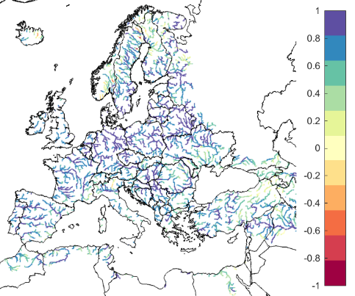
Figure 2: EFAS CRPSS at lead-time 1 day for the February 2021, for catchments >2000km2. The reference score is persistence of using previous day’s forecast.
Figure 2 and Figure 3 shows the EFAS headline score, the continuous ranked probability skill score (CRPSS) for lead times 1 and 5 days for February across the EFAS domain for catchments larger than 2000km2. A CRPSS of 1 indicates perfect skill, 0 indicates that the performance is equal to that of the reference, and any value <0 (shown in orange-red on the maps) indicates the skill is worse than the reference. The reference score is using yesterday’s forecast as today’s forecast, which is slightly different than we used previously and very difficult to beat.

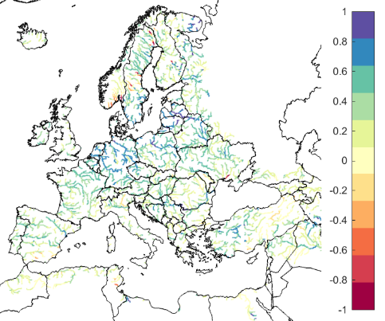
Figure 3. EFAS CRPSS at lead-time 5 days for February 2021 for catchments >2000km2. The reference score is persistence of using previous day’s forecast.
These maps indicate that across much of Europe for forecasts are more skilful than persistence at both lead times. Regions shown in blue are those where EFAS forecasts are more skilful than persistence, with darker shading indicating better performance.

The skill of the forecast was quite good over the period, and better compared to the same period last year (Figure 4). An inter-annual variability of the scores is to be expected. The long-term trend is neutral over the first two years since the domain was extended, but there is an indication of increase in skill with EFAS 4.0.
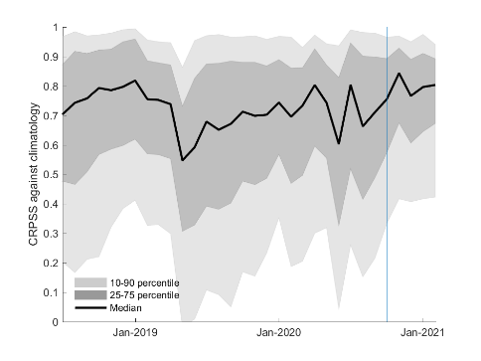
Figure 4. Monthly means of CRPSS the for lead-time 5 days for all the major river points in Europe with ECMWF ENS as forcing. Reference forecast was climatology. The skill is largest during the winter months, when there is less variation in the flow in large parts of Europe. The blue line indicates the release of EFAS 4.0.

ARTICLES

Suggest river gauge stations for the next EFAS calibration!

by Cinzia Mazzetti, Mercedes Garcia Padilla, Rafael Garcia and Christel Prudhomme

Call for data: EFAS partners can submit feedback on calibration stations until 30th June
As a starting point, EFAS Computational Centre (COMP) will consider all stations used for EFAS v4 calibration but will also assess if more stations in the EFAS Hydrological Data Collection Centre (HYDRO) database could be used for EFAS-next calibration. The selection process has already started, but there is still the opportunity for EFAS partners to contribute with new discharge data and take part in the selection of EFAS-next calibration stations! There are two ways you can take part:

- In the next few weeks, COMP and HYDRO will contact you with a list of already pre-selected calibration stations, and alternative/new candidates for EFAS-next. You can then provide feedback on the stations, for example by letting us know which stations should be avoided (e.g. because very old and no longer in use, or because of issues with the rating curve or the sensor), replaced by alternative stations nearby already within the HYDRO database, or by offering new stations.
- You can also contact HYDRO directly with new river discharge data. As described above, the length and quality of the river discharge time series observation are not the only criteria for selection, and it might be possible that a new candidate is not selected at the end, for example, if it cannot be located accurately in the EFAS river network. However, this is seldom the case.
Increasing the calibration domain (i.e. with more stations and longer time series) is a great way to improve the quality of the EFAS system, and we are very much looking forward to working with you to achieve this. However, as mapping and additional quality check procedures are long, we can only accept new candidate stations for EFAS-next calibration until the 30th June 2021, so that we have time to inspect the data before the calibration starts. Any data received after that date will of course be included in the HYDRO database and considered for future EFAS upgrades such as reporting point upgrades or another cycle of calibration.

Background
Like any operational forecasting systems, EFAS is always evolving with regular updates of the modelling chain, products, or information access. The latest upgrade, EFAS v4.2, includes 436 new fixed reporting points on the EFAS mapviewer (bringing the total number to 3087) so that users can monitor forecasts at their stations of interest. The next step-change in the EFAS modelling chain is an increase of the spatial resolution to a 1 arcminute grid (around 1.19km size at 50° latitude) with a small eastward widening of the domain, giving around 22 times more grid points compared with the EFAS v4 5-km grid (Figure 5). The resolution increase will come with a new calibration, which provides an opportunity for adding more calibration points.

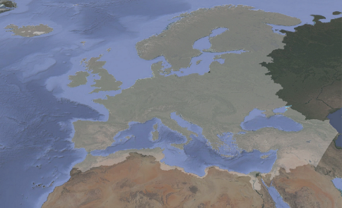
Figure 5: Full EFAS 1arcmin domain area, with EFAS v4 domain in lighter shade.
Hydrological model calibration
LISFLOOD is the hydrological model at the heart of EFAS. Developed at the JRC since 2000, it is now fully open-source maintained by the JRC with the support of the EFAS COMP at ECMWF.
LISFLOOD is a fully distributed hydrological model, which explicitly considers the spatial distribution of physical properties across catchments and provides estimates of river discharge on the entire geographical domain. Driven by meteorological forcing data, LISFLOOD calculates a complete water balance for every grid cell, with runoff then routed through the river network using a kinematic wave approach, including options to simulate lakes and reservoirs. The water balance estimates and routing rely on a set of parameters conceptualising the different hydrological processes.
Where long enough, good quality river discharge time-series observations are available, parameter sets are searched iteratively and tested by comparing observed time-series with LISFLOOD simulations forced with observed meteorological maps so that the parameter set best representing the hydrological behaviour of the catchment can be identified. This is a process known as ‘hydrological model calibration’. For catchments where there are no observations, default parameters are used along with land surface information when running LISFLOOD.

EFAS Calibration domain
The calibration process results in an improvement in the hydrological simulation performance. For EFAS to benefit from the best hydrological simulation everywhere, the catchments represented by the calibration stations should cover the largest area possible. For EFAS v4.0, calibration was performed using data from 1137 stations in 215 river basins covering 44.49% of the 9 million km2 EFAS spatial domain (Figure 6). The calibration stations were selected from the 2927 river gauging stations in the HYDRO database in July 2018 when calibration work began. Because of the limited availability of sub-daily river discharge data, catchment with 6-hourly data (the time step of EFAS from version 4) and daily data were both considered, which increased by 180% the calibration points against only using 6-hourly data.

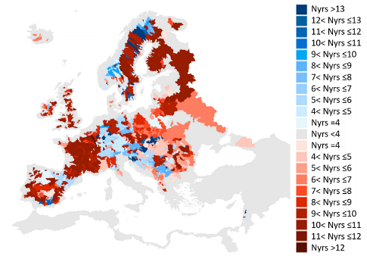
Figure 6: EFAS v4. calibration domain with 6-hourly (blue) and daily (red) calibration catchments. The colour strength shows the number of years with available data
Since then, the amount of river discharge time-series available in the HYDRO database has increased, benefiting from more data providers and a longer period of record. This gives an opportunity to extend the EFAS calibration domain for EFAS-next.

Identification of calibration stations
Not all stations with records available in the HYDRO database are appropriate for the EFAS calibration. First, the calibration relies on river discharge and stations with river level only data (and no rating curve) cannot be used. Second, the period of observational record needs to match with observed meteorological forcing data (1990 - 2021) and include at least 4 years of data. Third, the location of the station and the quality of the data are also considered so that the best overall calibration coverage can be achieved.

Locating the station on the EFAS river network
As already said, LISFLOOD is a distributed model based on a mesh of points organised on a regular grid. For EFAS-next, the grid has a 1 arcmin size. Using elevation information, LISFLOOD pixels are connected to reproduce the natural drainage network, but the spatial resolution of the grid and inaccuracies in pixels elevation can affect the representation of rivers in LISFLOOD from the real world. It is generally not a problem for hydrological modelling, but it becomes an issue when the drainage network of the model is compared to real-world locations. This means that it is necessary to map each gauge to the pixel where discharge from the model can best represent observations at the station. This is a long process based on metadata information (e.g. catchment area, river/station name) and manual inspections (e.g. using Google maps). Location of the station relative to river confluence (i.e. upstream or downstream) and/or presence of lakes and reservoirs are also considered, and if necessary, river gauges location on EFAS grid are shifted from their geographical coordinates by few pixels. Any error or inaccuracy in river stations metadata are reported to the HYDRO and stations that could not be mapped onto the model drainage network are flagged. The workflow involved is shown in Figure 7.

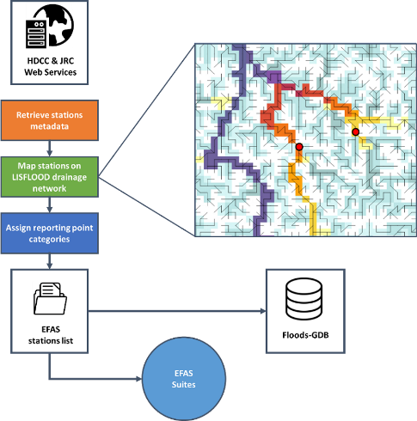
Figure 7: Workflow for locating hydrological gauging stations on the EFAS drainage network
River discharge data check
Data in the HYDRO database are inspected by COMP to identify available record length, low-quality data (e.g. missing/invalid data, outliers, location error), or influenced regime (e.g. from reservoirs/lakes). This is done using automatic procedures, statistical analysis (e.g. flow duration curves, annual hydrograph, annual totals) and visual time-series inspections. In addition to acceptable quality and reduced influence from reservoirs and lakes, calibration stations are selected according to the following criteria:
- Drained area: > 500 km2 for EFAS 5-km grid. For EFAS-next, we now will consider stations for catchments larger than 200 km2.
- Record length: >= 4 years (excluding missing data)
- Time step: sub-daily or daily (both historical and near real-time data are considered)
- Spatial coverage: as large as possible, including some tolerance on data quality and availability but excluding nearby stations on the same river branch, prioritising first sub-daily data and then longest available record

Part of the quality check procedure is the consistency between discharge values at adjacent river stations on the same river, the removal of outliers and suspicious zeros, and visual inspection of the time-series. At the end of the process, a data quality flag is associated with the station.

Don't forget to submit your feedback on calibration stations by the 30th of June!

Flash Floods in Greece and Turkey, Early February 2021

by Richard Davies, floodlist

Early February saw flash flooding in parts of north eastern Greece and western Turkey, where homes and vehicles were damaged. Three people tragically lost their lives in the floods, including one firefighter.

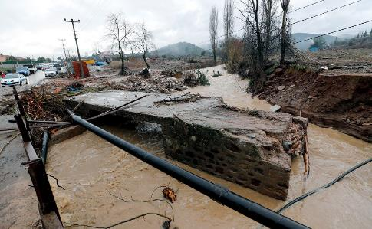
Figure 8: Flood damage in Menderes District, Izmir, Turkey, 02 February 202. Photo credit: Izmir Governorship/İzmir Valiliği
Greece
The fire-fighter died while carrying out flood rescues in north eastern Greece. The tragedy occurred in a village on the outskirts of Alexandroupolis in the Evros Region of Greece on 01 February 2021. Flash flooding was reported in other areas of the region, including in the city of Alexandroupolis and the town of Soufli.

Alexandroupolis saw around 200 mm of rain 01 to 02 February. Athens-Macedonian News Agency (AMNA) said “roads turned into rivers” in areas around the city. The Greek Fire Service helped evacuate people from flooded areas, including students and teachers from a secondary school. The service said it responded to a total of 55 calls for assistance in Alexandroupolis and 11 calls for assistance in Soufli, where damage to homes and businesses was reported. Prime Minister Kyriakos Mitsotakis and President Katerina Sakellaropoulou both expressed their condolences on the death of the firefighter.

Turkey
Severe flooding was also reported in Izmir Province of western Turkey during this period. Flooding blocked roads and caused widespread traffic disruption in the city of Izmir and surrounding districts on 02 February 2021. Around 50 homes and businesses as well as 40 vehicles were damaged. Local media reported 2 flood-related fatalities in Menderes district on 02 February 2021.

Turkey’s meteorological agency, Meteoroloji Genel Müdürlüğ (MGM) reported that 123.9mm of rain fell in 24 hours to 02 February in Konak district of İzmir and 130.9 mm in 24 hours to 03 February in Menderes district.

Acknowledgements

The following partner institutes and contributors are gratefully acknowledged for their contribution:

- DG GROW - Copernicus and DG ECHO for funding the EFAS Project
- All data providers including meteorological data providers, hydrological services & weather forecasting centres
- The EFAS Operational Centres
- Richard Davies, Floodlist.com

Cover image: Flood damage in Menderes District, Izmir, Turkey, 02 February 202. Photo credit: Izmir Governorship/İzmir Valiliği.

Appendix – figures

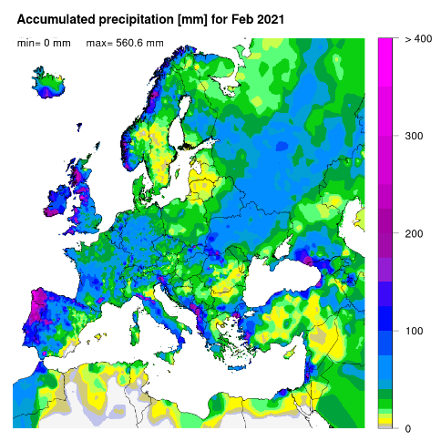
Figure 9: Accumulated precipitation [mm] for February 2021.
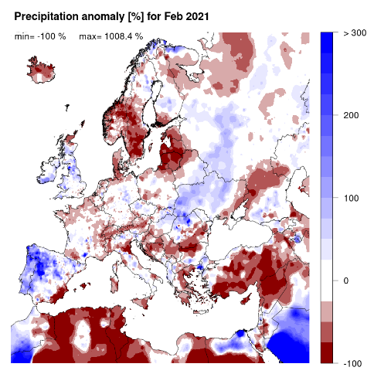
Figure 10: Precipitation anomaly [%] for February, relative to a long-term average (1990-2013). Blue (red) denotes wetter (drier) conditions than normal.

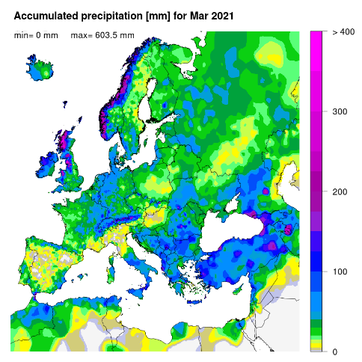
Figure 11: Accumulated precipitation [mm] for March.

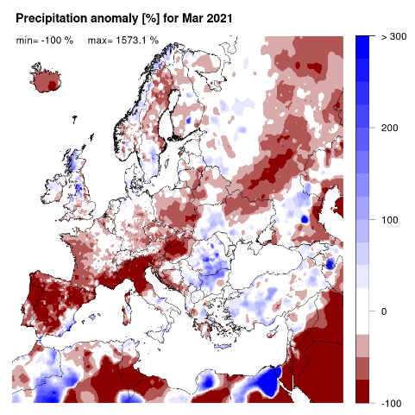
Figure 12: Precipitation anomaly [%] for March, relative to a long-term average (1990-2013). Blue (red) denotes wetter (drier) conditions than normal.
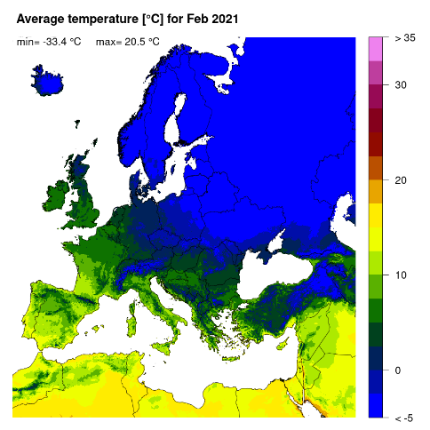
Figure 13: Mean temperature [°C] for February 2021.

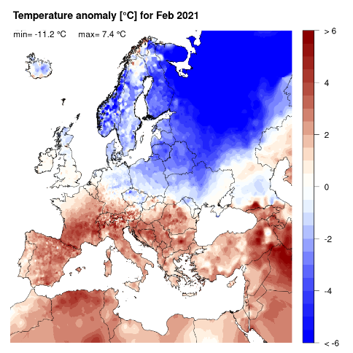
Figure 14: Temperature anomaly [°C] for February 2021, relative to a long-term average (1990-2013). Blue (red) denotes colder (warmer) temperatures than normal

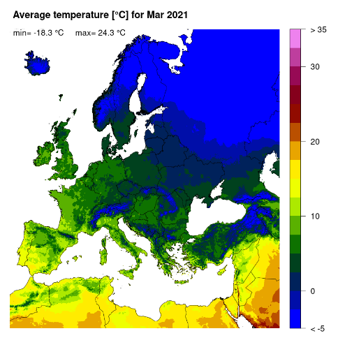
Figure 15: Mean temperature [°C] for March.

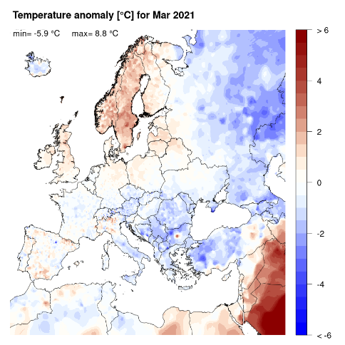
Figure 16: Temperature anomaly [°C] for March, relative to a long-term average (1990-2013). Blue (red) denotes colder (warmer) temperatures than normal.

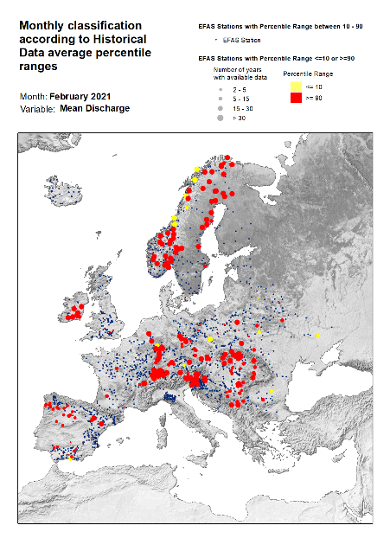
Figure 17: Monthly discharge anomalies February 2021.
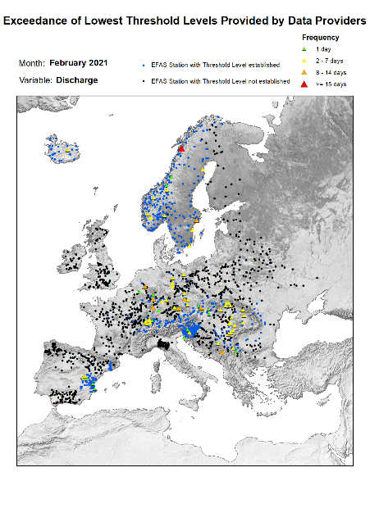
Figure 18: Lowest alert level exceedance for February
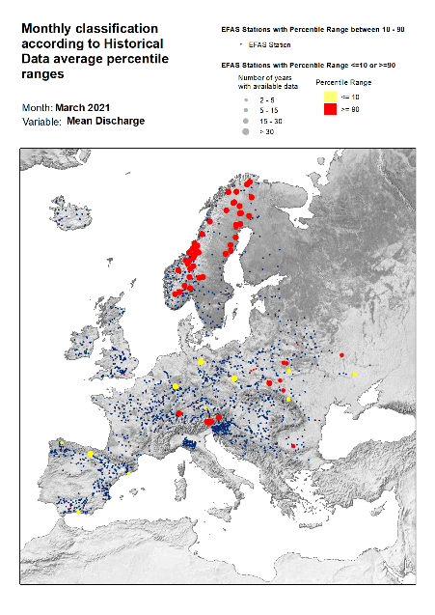
Figure 19: Monthly discharge anomalies March 2021.
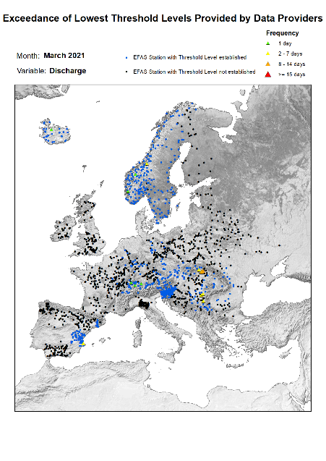
Figure 20: Lowest alert level exceedance for March 2021.
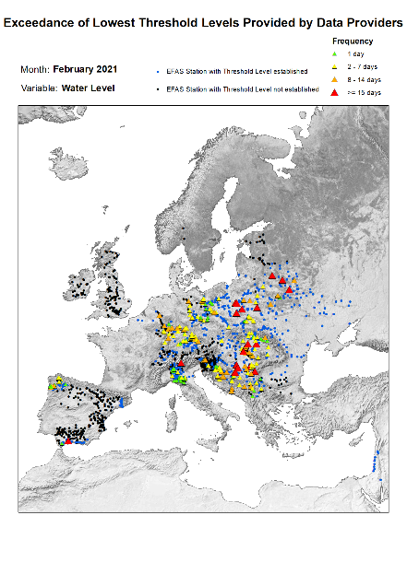
Figure 21: Lowest threshold exceedance for February 2021.
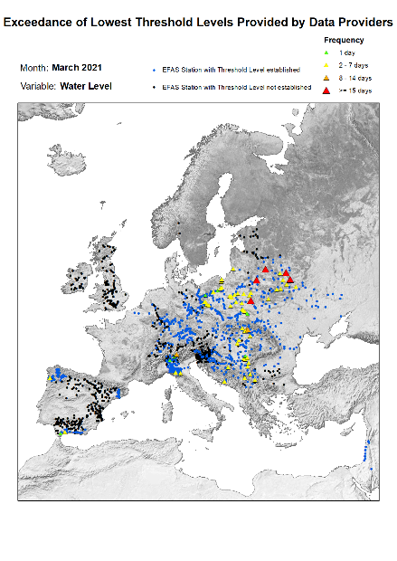
Figure 22: Lowest threshold exceedance for March 2021.

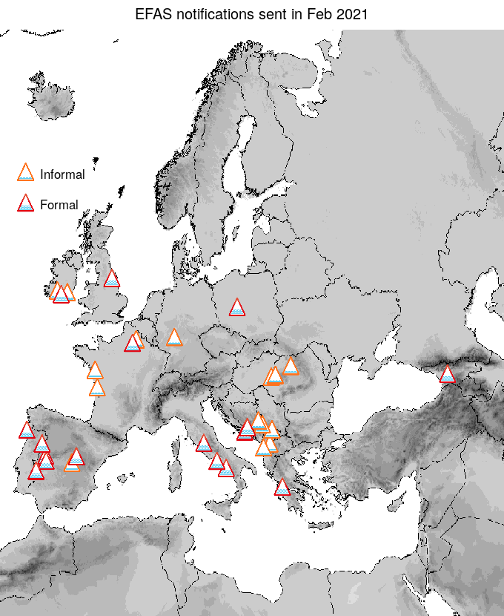
Figure 23: EFAS flood notifications sent for February.

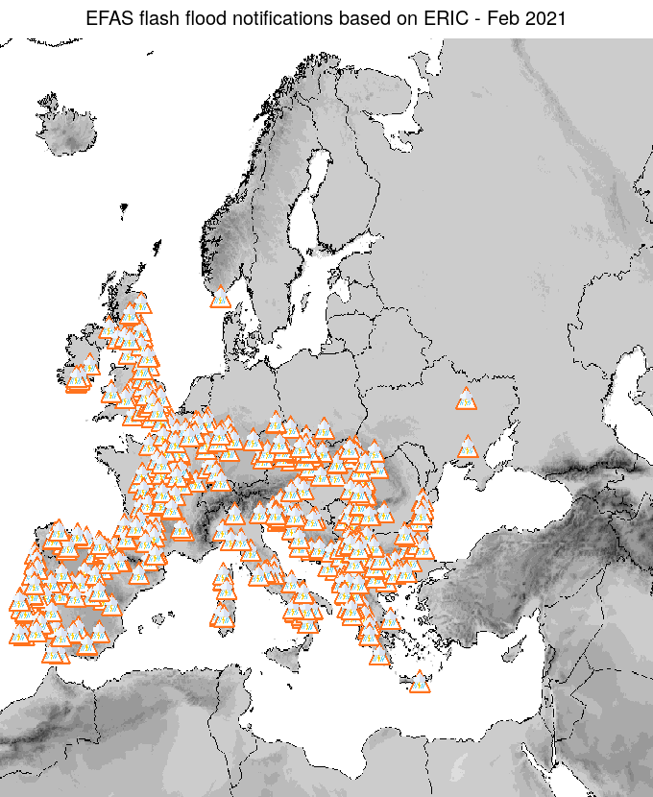
Figure 24: Flash flood notifications sent for February.
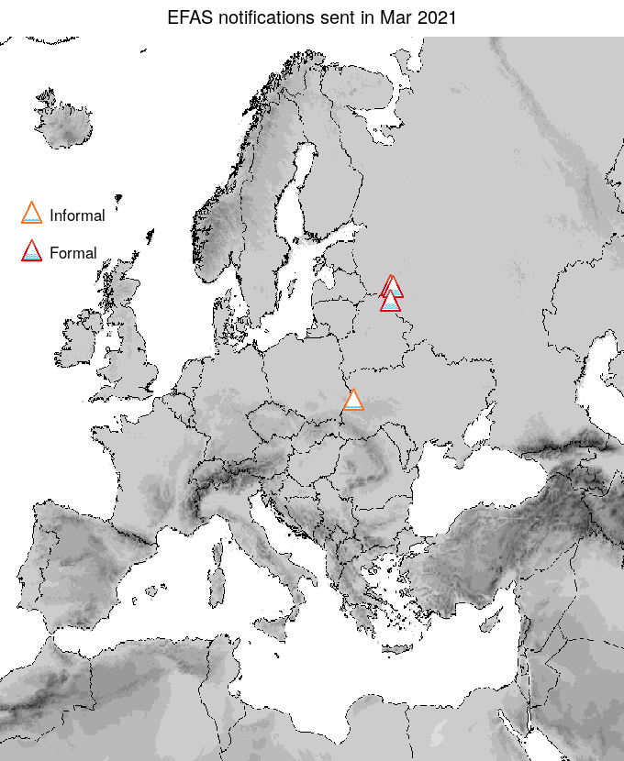
Figure 25: EFAS flood notifications sent for March.

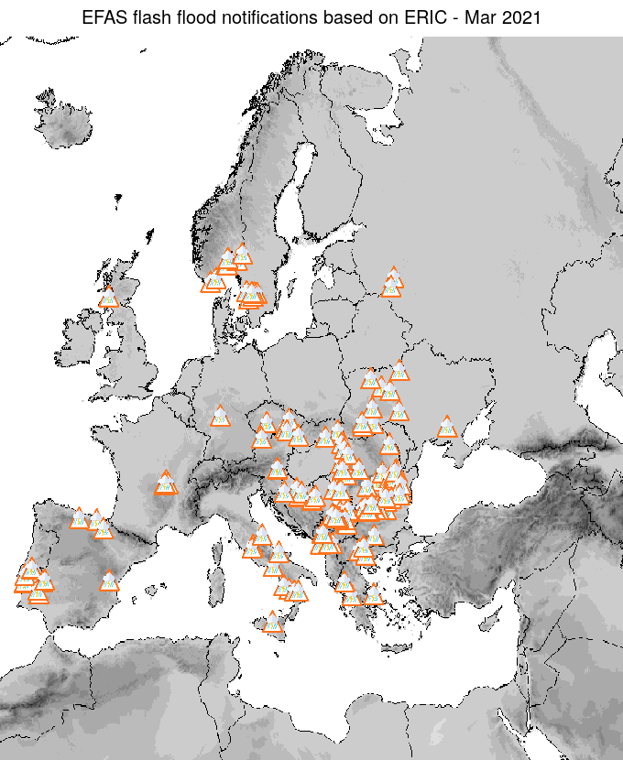
Figure 26: Flash flood notifications sent for March.

Appendix - tables
EUROPEAN FLOOD AWARENESS SYSTEM: Bimonthly Bulletin – Issue 2021(1)

Table 1: EFAS flood notifications sent in February - March
Type | Forecast date | Issue date | Lead time | River | Country
Informal Flood | 01/02/2021 00UTC | 01/02/2021 | 24 | Charente | France
Formal Flood | 02/02/2021 00UTC | 02/02/2021 | 84 | Rioni | Georgia
Informal Flood | 02/02/2021 00UTC | 02/02/2021 | 42 | Oise | France
Formal Flood | 02/02/2021 12UTC | 03/02/2021 | 30 | DERWENT (TRIB. NORTH SEA) | United Kingdom
Informal Flood | 02/02/2021 12UTC | 03/02/2021 | 30 | Nidda | Germany
Informal Flood | 03/02/2021 12UTC | 04/02/2021 | 78 | Loire | France
Formal Flood | 04/02/2021 00UTC | 04/02/2021 | 96 | Sele | Italy
Formal Flood | 04/02/2021 00UTC | 04/02/2021 | 102 | Nera | Italy
Formal Flood | 04/02/2021 12UTC | 04/02/2021 | 6 | Tietar | Spain
Formal Flood | 04/02/2021 12UTC | 04/02/2021 | 0 | Oise | France
Informal Flood | 04/02/2021 12UTC | 05/02/2021 | 90 | Black Drin | Albania
Formal Flood | 04/02/2021 12UTC | 04/02/2021 | 42 | Tajo | Spain
Formal Flood | 05/02/2021 00UTC | 05/02/2021 | 90 | Neretva | Croatia
Informal Flood | 05/02/2021 00UTC | 05/02/2021 | 84 | Neretva | Bosnia And Herzegovina
Formal Flood | 05/02/2021 12UTC | 06/02/2021 | 0 | Duoro, below Tormes | Spain
Formal Flood | 05/02/2021 12UTC | 06/02/2021 | 96 | Volturno | Italy
Formal Flood | 05/02/2021 12UTC | 06/02/2021 | 72 | Acheloos | Greece
Informal Flood | 06/02/2021 00UTC | 06/02/2021 | 60 | Somesul Mare | Romania
Informal Flood | 06/02/2021 00UTC | 06/02/2021 | 60 | Somesul Mare | Romania
Informal Flood | 06/02/2021 00UTC | 06/02/2021 | 60 | Somesul Mare | Romania
Informal Flood | 06/02/2021 00UTC | 06/02/2021 | 72 | Crisul Negru | Romania
Informal Flood | 06/02/2021 12UTC | 07/02/2021 | 42 | - | Kosovo
Formal Flood | 07/02/2021 12UTC | 08/02/2021 | 54 | Guadiana, below Zujar | Spain
Formal Flood | 08/02/2021 00UTC | 08/02/2021 | 48 | TEJO | Spain
Informal Flood | 09/02/2021 00UTC | 09/02/2021 | 24 | Mati | Albania
Informal Flood | 09/02/2021 12UTC | 10/02/2021 | 36 | Lim | Bosnia And Herzegovina
Informal Flood | 09/02/2021 12UTC | 10/02/2021 | 42 | Lim | Serbia
Informal Flood | 09/02/2021 12UTC | 10/02/2021 | 42 | Crisul Negru | Hungary
Informal Flood | 10/02/2021 00UTC | 10/02/2021 | 0 | Crisul Negru | Romania
Formal Flood | 12/02/2021 00UTC | 12/02/2021 | -97 | Neretva | Bosnia And Herzegovina
Formal Flood | 16/02/2021 12UTC | 17/02/2021 | 42 | Prosna | Poland
Formal Flood | 17/02/2021 12UTC | 18/02/2021 | 12 | Limia | Portugal
Formal Flood | 21/02/2021 00UTC | 21/02/2021 | 60 | Blackwater Youghal | Ireland
Informal Flood | 21/02/2021 12UTC | 22/02/2021 | 48 | Suir | Ireland
Informal Flood | 22/02/2021 00UTC | 22/02/2021 | 30 | Munster Blackwater | Ireland
Informal Flood | 22/02/2021 12UTC | 23/02/2021 | 42 | Tajo | Spain
Informal Flood | 03/03/2021 00UTC | 03/03/2021 | 72 | Bug, above Mukhavyets | Ukraine
Formal Flood | 28/03/2021 12UTC | 29/03/2021 | 120 | Daugava or Western Dvina | Russia
Formal Flood | 28/03/2021 12UTC | 29/03/2021 | 78 | Zapadnaya Dvina, above Mezha | Russia
Formal Flood | 30/03/2021 00UTC | 30/03/2021 | 78 | Kasplya | Russia
a. * Lead time [days] to the first forecasted exceedance of the 5-year simulated discharge threshold.

Table 2: EFAS flash flood notifications sent in February - March

Type | Forecast date | Issue date | Lead time | Region | Country
Flash Flood | 31/01/2021 12UTC | 01/02/2021 | 42 | Poltava | Ukraine
Flash Flood | 31/01/2021 12UTC | 01/02/2021 | 24 | Sumadijska oblast | Serbia
Flash Flood | 31/01/2021 12UTC | 01/02/2021 | 18 | Sliven | Bulgaria
Flash Flood | 31/01/2021 12UTC | 01/02/2021 | 36 | Campania | Italy
Flash Flood | 31/01/2021 12UTC | 01/02/2021 | 60 | North Yorkshire | United Kingdom
Flash Flood | 31/01/2021 12UTC | 01/02/2021 | 60 | East Yorkshire and Northern Lincolnshire | United Kingdom
Flash Flood | 31/01/2021 12UTC | 01/02/2021 | 18 | Kentriki Makedonia | Greece
Flash Flood | 31/01/2021 12UTC | 01/02/2021 | 42 | Leicestershire, Rutland and Northamptonshire | United Kingdom
Flash Flood | 31/01/2021 12UTC | 01/02/2021 | 30 | Pirotska oblast | Serbia
Flash Flood | 31/01/2021 12UTC | 01/02/2021 | 42 | Lincolnshire | United Kingdom
Flash Flood | 31/01/2021 12UTC | 01/02/2021 | 66 | Tees Valley and Durham | United Kingdom
Flash Flood | 31/01/2021 12UTC | 01/02/2021 | 18 | Pazardzhik | Bulgaria
Flash Flood | 31/01/2021 12UTC | 01/02/2021 | 12 | Beogradska oblast | Serbia
Flash Flood | 01/02/2021 00UTC | 01/02/2021 | 54 | Alto Minho | Portugal
Flash Flood | 01/02/2021 00UTC | 01/02/2021 | 36 | Shkoder | Albania
Flash Flood | 01/02/2021 00UTC | 01/02/2021 | 60 | Loir-et-Cher | France
Flash Flood | 01/02/2021 00UTC | 01/02/2021 | 12 | Aude | France
Flash Flood | 01/02/2021 00UTC | 01/02/2021 | 60 | Karlsruhe | Germany
Flash Flood | 01/02/2021 00UTC | 01/02/2021 | 54 | North Yorkshire | United Kingdom
Flash Flood | 01/02/2021 00UTC | 01/02/2021 | 60 | Leon | Spain
Flash Flood | 01/02/2021 00UTC | 01/02/2021 | 60 | Unterfranken | Germany
Flash Flood | 01/02/2021 00UTC | 01/02/2021 | 48 | Cumbria | United Kingdom
Flash Flood | 01/02/2021 00UTC | 01/02/2021 | 24 | Ariege | France
Flash Flood | 01/02/2021 00UTC | 01/02/2021 | 30 | Basilicata | Italy
Flash Flood | 01/02/2021 00UTC | 01/02/2021 | 48 | Lugo | Spain
Flash Flood | 01/02/2021 00UTC | 01/02/2021 | 48 | Cher | France
Flash Flood | 01/02/2021 00UTC | 01/02/2021 | 30 | Calabria | Italy
Flash Flood | 01/02/2021 00UTC | 01/02/2021 | 24 | Sardegna | Italy
Flash Flood | 01/02/2021 00UTC | 01/02/2021 | 36 | Dakovica | Kosovo
Flash Flood | 01/02/2021 00UTC | 01/02/2021 | 36 | Kosovska Mitrovica | Kosovo
Flash Flood | 01/02/2021 00UTC | 01/02/2021 | 36 | Kukes | Albania
Flash Flood | 01/02/2021 12UTC | 02/02/2021 | 60 | Jihomoravsky kraj | Czech Republic
Flash Flood | 01/02/2021 12UTC | 02/02/2021 | 60 | Olomoucky kraj | Czech Republic
Flash Flood | 01/02/2021 12UTC | 02/02/2021 | 48 | Prov. Namur | Belgium
Flash Flood | 01/02/2021 12UTC | 02/02/2021 | 24 | Prizren | Kosovo
Flash Flood | 01/02/2021 12UTC | 02/02/2021 | 54 | Trier | Germany
Flash Flood | 01/02/2021 12UTC | 02/02/2021 | 24 | Lezhe | Albania
Flash Flood | 01/02/2021 12UTC | 02/02/2021 | 54 | Jihocesky kraj | Czech Republic
Flash Flood | 01/02/2021 12UTC | 02/02/2021 | 54 | Plzensky kraj | Czech Republic
Flash Flood | 01/02/2021 12UTC | 02/02/2021 | 42 | Haute-Saone | France
Flash Flood | 01/02/2021 12UTC | 02/02/2021 | 48 | Vosges | France
Flash Flood | 01/02/2021 12UTC | 02/02/2021 | 60 | Kralovehradecky kraj | Czech Republic
Flash Flood | 01/02/2021 12UTC | 02/02/2021 | 54 | Aisne | France
Flash Flood | 01/02/2021 12UTC | 02/02/2021 | 48 | Yonne | France
Flash Flood | 01/02/2021 12UTC | 02/02/2021 | 24 | Crna Gora | Montenegro
Flash Flood | 01/02/2021 12UTC | 02/02/2021 | 54 | Marne | France
Flash Flood | 01/02/2021 12UTC | 02/02/2021 | 54 | Seine-et-Marne | France
Flash Flood | 01/02/2021 12UTC | 02/02/2021 | 42 | Indre-et-Loire | France
Flash Flood | 01/02/2021 12UTC | 02/02/2021 | 48 | Bas-Rhin | France
Flash Flood | 01/02/2021 12UTC | 02/02/2021 | 48 | Eure | France
Flash Flood | 01/02/2021 12UTC | 02/02/2021 | 48 | Niederbayern | Germany
Flash Flood | 01/02/2021 12UTC | 02/02/2021 | 48 | Loir-et-Cher | France
Flash Flood | 01/02/2021 12UTC | 02/02/2021 | 48 | Oberpfalz | Germany
Flash Flood | 01/02/2021 12UTC | 02/02/2021 | 48 | Freiburg | Germany
Flash Flood | 01/02/2021 12UTC | 02/02/2021 | 48 | Niederosterreich | Austria
Flash Flood | 01/02/2021 12UTC | 02/02/2021 | 54 | Saarland | Germany
Flash Flood | 01/02/2021 12UTC | 02/02/2021 | 60 | Kraj Vysocina | Czech Republic
Flash Flood | 02/02/2021 00UTC | 02/02/2021 | 36 | Hampshire and Isle of Wight | United Kingdom
Flash Flood | 02/02/2021 00UTC | 02/02/2021 | 60 | Slaskie | Poland
Flash Flood | 02/02/2021 00UTC | 02/02/2021 | 60 | Caras-Severin | Romania
Flash Flood | 02/02/2021 00UTC | 02/02/2021 | 42 | Outer London - East and North East | United Kingdom
Flash Flood | 02/02/2021 00UTC | 02/02/2021 | 54 | Transcarpathia | Ukraine
Flash Flood | 02/02/2021 00UTC | 02/02/2021 | 36 | Bedfordshire and Hertfordshire | United Kingdom
Flash Flood | 02/02/2021 00UTC | 02/02/2021 | 36 | Surrey, East and West Sussex | United Kingdom
Flash Flood | 02/02/2021 00UTC | 02/02/2021 | 36 | Kent | United Kingdom
Flash Flood | 02/02/2021 00UTC | 02/02/2021 | 48 | Presovsky kraj | Slovakia
Flash Flood | 02/02/2021 00UTC | 02/02/2021 | 54 | Maramures | Romania
Flash Flood | 02/02/2021 00UTC | 02/02/2021 | 54 | Arad | Romania
Flash Flood | 02/02/2021 00UTC | 02/02/2021 | 36 | Essex | United Kingdom
Flash Flood | 02/02/2021 00UTC | 02/02/2021 | 12 | East Anglia | United Kingdom
Flash Flood | 02/02/2021 00UTC | 02/02/2021 | 36 | Giessen | Germany
Flash Flood | 02/02/2021 12UTC | 03/02/2021 | 54 | Medio Tejo | Portugal
Flash Flood | 02/02/2021 12UTC | 03/02/2021 | 24 | Pas-de-Calais | France
Flash Flood | 02/02/2021 12UTC | 03/02/2021 | 48 | Alto Alentejo | Portugal
Flash Flood | 02/02/2021 12UTC | 03/02/2021 | 42 | Satu Mare | Romania
Flash Flood | 02/02/2021 12UTC | 03/02/2021 | 42 | Hunedoara | Romania
Flash Flood | 02/02/2021 12UTC | 03/02/2021 | 42 | Cluj | Romania
Flash Flood | 02/02/2021 12UTC | 03/02/2021 | 54 | Kherson | Ukraine
Flash Flood | 02/02/2021 12UTC | 03/02/2021 | 36 | Kosicky kraj | Slovakia
Flash Flood | 02/02/2021 12UTC | 03/02/2021 | 24 | Toledo | Spain
Flash Flood | 02/02/2021 12UTC | 03/02/2021 | 24 | Freiburg | Germany
Flash Flood | 02/02/2021 12UTC | 03/02/2021 | 24 | Caceres | Spain
Flash Flood | 02/02/2021 12UTC | 03/02/2021 | 48 | Salamanca | Spain
Flash Flood | 02/02/2021 12UTC | 03/02/2021 | 54 | Leziria do Tejo | Portugal
Flash Flood | 02/02/2021 12UTC | 03/02/2021 | 48 | Baixo Alentejo | Portugal
Flash Flood | 02/02/2021 12UTC | 03/02/2021 | 36 | Eszak-Magyarorszag | Hungary
Flash Flood | 02/02/2021 12UTC | 03/02/2021 | 24 | Prov. West-Vlaanderen | Belgium
Flash Flood | 02/02/2021 12UTC | 03/02/2021 | 42 | Bihor | Romania
Flash Flood | 02/02/2021 12UTC | 03/02/2021 | 30 | Southern Scotland | United Kingdom
Flash Flood | 02/02/2021 12UTC | 03/02/2021 | 48 | Dresden | Germany
Flash Flood | 02/02/2021 12UTC | 03/02/2021 | 24 | Nord | France
Flash Flood | 02/02/2021 12UTC | 03/02/2021 | 36 | Moravskoslezsky kraj | Czech Republic
Flash Flood | 02/02/2021 12UTC | 03/02/2021 | 48 | Bistrita-Nasaud | Romania
Flash Flood | 02/02/2021 12UTC | 03/02/2021 | 42 | Alba | Romania
Flash Flood | 02/02/2021 12UTC | 03/02/2021 | 24 | Northumberland and Tyne and Wear | United Kingdom
Flash Flood | 02/02/2021 12UTC | 03/02/2021 | 24 | Eastern Scotland | United Kingdom
Flash Flood | 03/02/2021 00UTC | 03/02/2021 | 42 | Regiao de Coimbra | Portugal
Flash Flood | 03/02/2021 00UTC | 03/02/2021 | 48 | Oeste | Portugal
Flash Flood | 03/02/2021 00UTC | 03/02/2021 | 24 | Oberfranken | Germany
Flash Flood | 03/02/2021 00UTC | 03/02/2021 | 48 | Regiao de Leiria | Portugal
Flash Flood | 03/02/2021 12UTC | 04/02/2021 | 24 | Timis | Romania
Flash Flood | 03/02/2021 12UTC | 04/02/2021 | 30 | Alentejo Litoral | Portugal
Flash Flood | 03/02/2021 12UTC | 04/02/2021 | 60 | Cantabria | Spain
Flash Flood | 03/02/2021 12UTC | 04/02/2021 | 30 | Area Metropolitana de Lisboa | Portugal
Flash Flood | 03/02/2021 12UTC | 04/02/2021 | 24 | Southern Scotland | United Kingdom
Flash Flood | 03/02/2021 12UTC | 04/02/2021 | 30 | Avila | Spain
Flash Flood | 03/02/2021 12UTC | 04/02/2021 | 24 | Region Vojvodine | Serbia
Flash Flood | 03/02/2021 12UTC | 04/02/2021 | 36 | North Eastern Scotland | United Kingdom
Flash Flood | 03/02/2021 12UTC | 04/02/2021 | 24 | Highlands and Islands | United Kingdom
Flash Flood | 04/02/2021 00UTC | 04/02/2021 | 54 | Kraj Vysocina | Czech Republic
Flash Flood | 04/02/2021 00UTC | 04/02/2021 | 42 | Beira Baixa | Portugal
Flash Flood | 04/02/2021 00UTC | 04/02/2021 | 54 | Loir-et-Cher | France
Flash Flood | 04/02/2021 00UTC | 04/02/2021 | 54 | Indre-et-Loire | France
Flash Flood | 04/02/2021 00UTC | 04/02/2021 | 54 | Darmstadt | Germany
Flash Flood | 04/02/2021 00UTC | 04/02/2021 | 30 | Soria | Spain
Flash Flood | 04/02/2021 00UTC | 04/02/2021 | 66 | Cher | France
Flash Flood | 04/02/2021 00UTC | 04/02/2021 | 18 | Gloucestershire, Wiltshire and Bristol/Bath area | United Kingdom
Flash Flood | 04/02/2021 00UTC | 04/02/2021 | 18 | Herefordshire, Worcestershire and Warwickshire | United Kingdom
Flash Flood | 04/02/2021 00UTC | 04/02/2021 | 24 | East Yorkshire and Northern Lincolnshire | United Kingdom
Flash Flood | 04/02/2021 00UTC | 04/02/2021 | 24 | North Yorkshire | United Kingdom
Flash Flood | 04/02/2021 00UTC | 04/02/2021 | 60 | Indre | France
Flash Flood | 04/02/2021 00UTC | 04/02/2021 | 54 | Bizkaia | Spain
Flash Flood | 04/02/2021 00UTC | 04/02/2021 | 42 | Asturias | Spain
Flash Flood | 04/02/2021 00UTC | 04/02/2021 | 30 | Segovia | Spain
Flash Flood | 04/02/2021 00UTC | 04/02/2021 | 30 | Avila | Spain
Flash Flood | 04/02/2021 00UTC | 04/02/2021 | 48 | Guadalajara | Spain
Flash Flood | 04/02/2021 00UTC | 04/02/2021 | 30 | Tees Valley and Durham | United Kingdom
Flash Flood | 04/02/2021 00UTC | 04/02/2021 | 18 | Southern Scotland | United Kingdom
Flash Flood | 04/02/2021 00UTC | 04/02/2021 | 18 | Northumberland and Tyne and Wear | United Kingdom
Flash Flood | 04/02/2021 00UTC | 04/02/2021 | 54 | Olomoucky kraj | Czech Republic
Flash Flood | 04/02/2021 00UTC | 04/02/2021 | 54 | Jihomoravsky kraj | Czech Republic
Flash Flood | 04/02/2021 00UTC | 04/02/2021 | 54 | Eszak-Magyarorszag | Hungary
Flash Flood | 04/02/2021 00UTC | 04/02/2021 | 60 | Stredocesky kraj | Czech Republic
Flash Flood | 04/02/2021 00UTC | 04/02/2021 | 42 | Sevilla | Spain
Flash Flood | 04/02/2021 00UTC | 04/02/2021 | 60 | Unterfranken | Germany
Flash Flood | 04/02/2021 00UTC | 04/02/2021 | 66 | Maine-et-Loire | France
Flash Flood | 04/02/2021 00UTC | 04/02/2021 | 60 | Eure-et-Loir | France
Flash Flood | 04/02/2021 12UTC | 04/02/2021 | 54 | Lot-et-Garonne | France
Flash Flood | 04/02/2021 12UTC | 04/02/2021 | 54 | Derbyshire and Nottinghamshire | United Kingdom
Flash Flood | 04/02/2021 12UTC | 04/02/2021 | 60 | Surrey, East and West Sussex | United Kingdom
Flash Flood | 04/02/2021 12UTC | 04/02/2021 | 60 | Somme | France
Flash Flood | 04/02/2021 12UTC | 04/02/2021 | 54 | Leicestershire, Rutland and Northamptonshire | United Kingdom
Flash Flood | 04/02/2021 12UTC | 04/02/2021 | 54 | East Anglia | United Kingdom
Flash Flood | 04/02/2021 12UTC | 04/02/2021 | 54 | Bedfordshire and Hertfordshire | United Kingdom
Flash Flood | 04/02/2021 12UTC | 04/02/2021 | 60 | Essex | United Kingdom
Flash Flood | 04/02/2021 12UTC | 04/02/2021 | 60 | Kent | United Kingdom
Flash Flood | 04/02/2021 12UTC | 04/02/2021 | 54 | Essonne | France
Flash Flood | 04/02/2021 12UTC | 04/02/2021 | 54 | Seine-et-Marne | France
Flash Flood | 04/02/2021 12UTC | 04/02/2021 | 54 | Vienne | France
Flash Flood | 04/02/2021 12UTC | 04/02/2021 | 54 | Jaen | Spain
Flash Flood | 04/02/2021 12UTC | 04/02/2021 | 48 | Landes | France
Flash Flood | 04/02/2021 12UTC | 04/02/2021 | 48 | Gironde | France
Flash Flood | 04/02/2021 12UTC | 04/02/2021 | 54 | Dordogne | France
Flash Flood | 04/02/2021 12UTC | 04/02/2021 | 54 | Sarthe | France
Flash Flood | 04/02/2021 12UTC | 04/02/2021 | 54 | Charente | France
Flash Flood | 04/02/2021 12UTC | 04/02/2021 | 24 | Algarve | Portugal
Flash Flood | 04/02/2021 12UTC | 04/02/2021 | 60 | Drome | France
Flash Flood | 04/02/2021 12UTC | 04/02/2021 | 60 | Ardeche | France
Flash Flood | 04/02/2021 12UTC | 04/02/2021 | 48 | Huesca | Spain
Flash Flood | 04/02/2021 12UTC | 04/02/2021 | 48 | Navarra | Spain
Flash Flood | 04/02/2021 12UTC | 04/02/2021 | 6 | Badajoz | Spain
Flash Flood | 04/02/2021 12UTC | 04/02/2021 | 60 | Puy-de-Dome | France
Flash Flood | 04/02/2021 12UTC | 04/02/2021 | 60 | Allier | France
Flash Flood | 04/02/2021 12UTC | 04/02/2021 | 48 | Burgos | Spain
Flash Flood | 04/02/2021 12UTC | 04/02/2021 | 60 | Saone-et-Loire | France
Flash Flood | 04/02/2021 12UTC | 04/02/2021 | 60 | Nievre | France
Flash Flood | 04/02/2021 12UTC | 04/02/2021 | 60 | Oise | France
Flash Flood | 04/02/2021 12UTC | 04/02/2021 | 54 | Aisne | France
Flash Flood | 05/02/2021 00UTC | 05/02/2021 | 60 | Dusseldorf | Germany
Flash Flood | 05/02/2021 00UTC | 05/02/2021 | 30 | Jihocesky kraj | Czech Republic
Flash Flood | 05/02/2021 00UTC | 05/02/2021 | 42 | Stredocesky kraj | Czech Republic
Flash Flood | 05/02/2021 00UTC | 05/02/2021 | 54 | Piemonte | Italy
Flash Flood | 05/02/2021 00UTC | 05/02/2021 | 48 | Giessen | Germany
Flash Flood | 05/02/2021 00UTC | 05/02/2021 | 48 | Koblenz | Germany
Flash Flood | 05/02/2021 00UTC | 05/02/2021 | 60 | Karnten | Austria
Flash Flood | 05/02/2021 00UTC | 05/02/2021 | 60 | Lombardia | Italy
Flash Flood | 05/02/2021 00UTC | 05/02/2021 | 42 | Marne | France
Flash Flood | 05/02/2021 00UTC | 05/02/2021 | 48 | Yonne | France
Flash Flood | 05/02/2021 00UTC | 05/02/2021 | 42 | Loiret | France
Flash Flood | 05/02/2021 00UTC | 05/02/2021 | 42 | Marne | France
Flash Flood | 05/02/2021 00UTC | 05/02/2021 | 60 | Corse-du-Sud | France
Flash Flood | 05/02/2021 00UTC | 05/02/2021 | 30 | Kraj Vysocina | Czech Republic
Flash Flood | 05/02/2021 00UTC | 05/02/2021 | 42 | Haute-Vienne | France
Flash Flood | 05/02/2021 00UTC | 05/02/2021 | 60 | Dusseldorf | Germany
Flash Flood | 05/02/2021 00UTC | 05/02/2021 | 60 | Friuli-Venezia Giulia | Italy
Flash Flood | 05/02/2021 12UTC | 06/02/2021 | 60 | Shkoder | Albania
Flash Flood | 05/02/2021 12UTC | 06/02/2021 | 60 | Kukes | Albania
Flash Flood | 05/02/2021 12UTC | 06/02/2021 | 60 | Crna Gora | Montenegro
Flash Flood | 05/02/2021 12UTC | 06/02/2021 | 24 | Lincolnshire | United Kingdom
Flash Flood | 05/02/2021 12UTC | 06/02/2021 | 36 | Outer London - East and North East | United Kingdom
Flash Flood | 05/02/2021 12UTC | 06/02/2021 | 30 | Inner London - East | United Kingdom
Flash Flood | 05/02/2021 12UTC | 06/02/2021 | 30 | Creuse | France
Flash Flood | 05/02/2021 12UTC | 06/02/2021 | 30 | Correze | France
Flash Flood | 05/02/2021 12UTC | 06/02/2021 | 36 | Lot | France
Flash Flood | 05/02/2021 12UTC | 06/02/2021 | 24 | Pyrenees-Atlantiques | France
Flash Flood | 05/02/2021 12UTC | 06/02/2021 | 36 | Nord | France
Flash Flood | 05/02/2021 12UTC | 06/02/2021 | 36 | Cote-dOr | France
Flash Flood | 05/02/2021 12UTC | 06/02/2021 | 36 | Koblenz | Germany
Flash Flood | 05/02/2021 12UTC | 06/02/2021 | 54 | Nitriansky kraj | Slovakia
Flash Flood | 05/02/2021 12UTC | 06/02/2021 | 60 | Bratislavsky kraj | Slovakia
Flash Flood | 05/02/2021 12UTC | 06/02/2021 | 60 | Trenciansky kraj | Slovakia
Flash Flood | 05/02/2021 12UTC | 06/02/2021 | 60 | Trnavsky kraj | Slovakia
Flash Flood | 05/02/2021 12UTC | 06/02/2021 | 60 | Zilinsky kraj | Slovakia
Flash Flood | 05/02/2021 12UTC | 06/02/2021 | 42 | Koln | Germany
Flash Flood | 05/02/2021 12UTC | 06/02/2021 | 42 | Prov. Limburg (BE) | Belgium
Flash Flood | 05/02/2021 12UTC | 06/02/2021 | 60 | Eszak-Alfold | Hungary
Flash Flood | 05/02/2021 12UTC | 06/02/2021 | 66 | Kosicky kraj | Slovakia
Flash Flood | 05/02/2021 12UTC | 06/02/2021 | 48 | Liguria | Italy
Flash Flood | 05/02/2021 12UTC | 06/02/2021 | 60 | Regiao de Aveiro | Portugal
Flash Flood | 05/02/2021 12UTC | 06/02/2021 | 60 | Banskobystricky kraj | Slovakia
Flash Flood | 05/02/2021 12UTC | 06/02/2021 | 24 | Araba/Alava | Spain
Flash Flood | 05/02/2021 12UTC | 06/02/2021 | 12 | Madrid | Spain
Flash Flood | 05/02/2021 12UTC | 06/02/2021 | 60 | Transcarpathia | Ukraine
Flash Flood | 05/02/2021 12UTC | 06/02/2021 | 60 | Raska oblast | Serbia
Flash Flood | 05/02/2021 12UTC | 06/02/2021 | 60 | Splitsko-dalmatinska zupanija | Croatia
Flash Flood | 05/02/2021 12UTC | 06/02/2021 | 60 | Republika Srpska | Bosnia And Herzegovina
Flash Flood | 05/02/2021 12UTC | 06/02/2021 | 54 | Federacija Bosna i Hercegovina | Bosnia And Herzegovina
Flash Flood | 05/02/2021 12UTC | 06/02/2021 | 54 | Osrednjeslovenska | Slovenia
Flash Flood | 05/02/2021 12UTC | 06/02/2021 | 60 | Zasavska | Slovenia
Flash Flood | 05/02/2021 12UTC | 06/02/2021 | 60 | Nyugat-Dunantul | Hungary
Flash Flood | 05/02/2021 12UTC | 06/02/2021 | 36 | Aube | France
Flash Flood | 05/02/2021 12UTC | 06/02/2021 | 18 | Valladolid | Spain
Flash Flood | 05/02/2021 12UTC | 06/02/2021 | 60 | Calabria | Italy
Flash Flood | 05/02/2021 12UTC | 06/02/2021 | 24 | South Yorkshire | United Kingdom
Flash Flood | 05/02/2021 12UTC | 06/02/2021 | 54 | Primorsko-goranska zupanija | Croatia
Flash Flood | 05/02/2021 12UTC | 06/02/2021 | 60 | Campania | Italy
Flash Flood | 05/02/2021 12UTC | 06/02/2021 | 54 | Abruzzo | Italy
Flash Flood | 05/02/2021 12UTC | 06/02/2021 | 54 | Umbria | Italy
Flash Flood | 05/02/2021 12UTC | 06/02/2021 | 60 | Marche | Italy
Flash Flood | 05/02/2021 12UTC | 06/02/2021 | 54 | Sardegna | Italy
Flash Flood | 05/02/2021 12UTC | 06/02/2021 | 54 | Istarska zupanija | Croatia
Flash Flood | 05/02/2021 12UTC | 06/02/2021 | 36 | Aude | France
Flash Flood | 05/02/2021 12UTC | 06/02/2021 | 60 | Burgenland | Austria
Flash Flood | 05/02/2021 12UTC | 06/02/2021 | 60 | Dubrovacko-neretvanska zupanija | Croatia
Flash Flood | 05/02/2021 12UTC | 06/02/2021 | 60 | Basilicata | Italy
Flash Flood | 05/02/2021 12UTC | 06/02/2021 | 54 | Toscana | Italy
Flash Flood | 05/02/2021 12UTC | 06/02/2021 | 66 | Bihor | Romania
Flash Flood | 05/02/2021 12UTC | 06/02/2021 | 60 | Dakovica | Kosovo
Flash Flood | 05/02/2021 12UTC | 06/02/2021 | 60 | Pecki | Kosovo
Flash Flood | 06/02/2021 00UTC | 06/02/2021 | 24 | Prov. Namur | Belgium
Flash Flood | 06/02/2021 00UTC | 06/02/2021 | 42 | Obalno-kraska | Slovenia
Flash Flood | 06/02/2021 00UTC | 06/02/2021 | 60 | Steiermark | Austria
Flash Flood | 06/02/2021 00UTC | 06/02/2021 | 42 | Veneto | Italy
Flash Flood | 06/02/2021 00UTC | 06/02/2021 | 54 | Licko-senjska zupanija | Croatia
Flash Flood | 06/02/2021 00UTC | 06/02/2021 | 54 | Sibensko-kninska zupanija | Croatia
Flash Flood | 06/02/2021 00UTC | 06/02/2021 | 48 | Zlatiborska oblast | Serbia
Flash Flood | 06/02/2021 00UTC | 06/02/2021 | 42 | Lazio | Italy
Flash Flood | 06/02/2021 00UTC | 06/02/2021 | 60 | Branicevska oblast | Serbia
Flash Flood | 06/02/2021 00UTC | 06/02/2021 | 60 | Zajecarska oblast | Serbia
Flash Flood | 06/02/2021 00UTC | 06/02/2021 | 60 | Pomoravska oblast | Serbia
Flash Flood | 06/02/2021 00UTC | 06/02/2021 | 60 | Dytiki Makedonia | Greece
Flash Flood | 06/02/2021 00UTC | 06/02/2021 | 60 | Sterea Ellada | Greece
Flash Flood | 06/02/2021 00UTC | 06/02/2021 | 60 | Kyustendil | Bulgaria
Flash Flood | 06/02/2021 00UTC | 06/02/2021 | 60 | Thessalia | Greece
Flash Flood | 06/02/2021 00UTC | 06/02/2021 | 60 | Ipeiros | Greece
Flash Flood | 06/02/2021 00UTC | 06/02/2021 | 60 | Poloski | N. Macedonia
Flash Flood | 06/02/2021 00UTC | 06/02/2021 | 60 | Jugozapaden | N. Macedonia
Flash Flood | 06/02/2021 00UTC | 06/02/2021 | 54 | Rasinska oblast | Serbia
Flash Flood | 06/02/2021 00UTC | 06/02/2021 | 60 | Nisavska oblast | Serbia
Flash Flood | 06/02/2021 00UTC | 06/02/2021 | 60 | Toplicka oblast | Serbia
Flash Flood | 06/02/2021 00UTC | 06/02/2021 | 60 | Pcinjska oblast | Serbia
Flash Flood | 06/02/2021 00UTC | 06/02/2021 | 54 | Kosovska Mitrovica | Kosovo
Flash Flood | 06/02/2021 00UTC | 06/02/2021 | 54 | Prizren | Kosovo
Flash Flood | 06/02/2021 00UTC | 06/02/2021 | 60 | Elbasan | Albania
Flash Flood | 06/02/2021 00UTC | 06/02/2021 | 60 | Berat | Albania
Flash Flood | 06/02/2021 00UTC | 06/02/2021 | 60 | Gjirokaster | Albania
Flash Flood | 06/02/2021 00UTC | 06/02/2021 | 24 | Prov. Liege | Belgium
Flash Flood | 06/02/2021 00UTC | 06/02/2021 | 24 | Prov. Hainaut | Belgium
Flash Flood | 06/02/2021 00UTC | 06/02/2021 | 24 | Limburg (NL) | Netherlands
Flash Flood | 06/02/2021 00UTC | 06/02/2021 | 48 | Zlinsky kraj | Czech Republic
Flash Flood | 06/02/2021 00UTC | 06/02/2021 | 60 | Ivano-Frankivs'k | Ukraine
Flash Flood | 06/02/2021 00UTC | 06/02/2021 | 54 | Presovsky kraj | Slovakia
Flash Flood | 06/02/2021 00UTC | 06/02/2021 | 60 | Caras-Severin | Romania
Flash Flood | 06/02/2021 00UTC | 06/02/2021 | 42 | Primorsko-notranjska | Slovenia
Flash Flood | 06/02/2021 00UTC | 06/02/2021 | 48 | Alto Alentejo | Portugal
Flash Flood | 06/02/2021 00UTC | 06/02/2021 | 24 | Ardennes | France
Flash Flood | 06/02/2021 00UTC | 06/02/2021 | 48 | Area Metropolitana do Porto | Portugal
Flash Flood | 06/02/2021 00UTC | 06/02/2021 | 54 | Lezhe | Albania
Flash Flood | 06/02/2021 00UTC | 06/02/2021 | 60 | Skopski | N. Macedonia
Flash Flood | 06/02/2021 12UTC | 07/02/2021 | 6 | Cher | France
Flash Flood | 06/02/2021 12UTC | 07/02/2021 | 42 | Alentejo Central | Portugal
Flash Flood | 06/02/2021 12UTC | 07/02/2021 | 54 | Plovdiv | Bulgaria
Flash Flood | 06/02/2021 12UTC | 07/02/2021 | 6 | Allier | France
Flash Flood | 06/02/2021 12UTC | 07/02/2021 | 12 | Ardennes | France
Flash Flood | 06/02/2021 12UTC | 07/02/2021 | 36 | Zadarska zupanija | Croatia
Flash Flood | 06/02/2021 12UTC | 07/02/2021 | 48 | Sumadijska oblast | Serbia
Flash Flood | 06/02/2021 12UTC | 07/02/2021 | 54 | Jugoistocen | N. Macedonia
Flash Flood | 06/02/2021 12UTC | 07/02/2021 | 12 | Bedfordshire and Hertfordshire | United Kingdom
Flash Flood | 06/02/2021 12UTC | 07/02/2021 | 54 | Haskovo | Bulgaria
Flash Flood | 06/02/2021 12UTC | 07/02/2021 | 12 | Prov. Luxembourg (BE) | Belgium
Flash Flood | 06/02/2021 12UTC | 07/02/2021 | 54 | Yambol | Bulgaria
Flash Flood | 06/02/2021 12UTC | 07/02/2021 | 54 | Valcea | Romania
Flash Flood | 06/02/2021 12UTC | 07/02/2021 | 54 | Satu Mare | Romania
Flash Flood | 06/02/2021 12UTC | 07/02/2021 | 54 | Sliven | Bulgaria
Flash Flood | 06/02/2021 12UTC | 07/02/2021 | 18 | Kent | United Kingdom
Flash Flood | 06/02/2021 12UTC | 07/02/2021 | 6 | Gironde | France
Flash Flood | 06/02/2021 12UTC | 07/02/2021 | 6 | Lot | France
Flash Flood | 06/02/2021 12UTC | 07/02/2021 | 6 | Landes | France
Flash Flood | 06/02/2021 12UTC | 07/02/2021 | 42 | Malaga | Spain
Flash Flood | 06/02/2021 12UTC | 07/02/2021 | 42 | Jaen | Spain
Flash Flood | 06/02/2021 12UTC | 07/02/2021 | 42 | Baixo Alentejo | Portugal
Flash Flood | 06/02/2021 12UTC | 07/02/2021 | 60 | Aude | France
Flash Flood | 06/02/2021 12UTC | 07/02/2021 | 6 | Bizkaia | Spain
Flash Flood | 06/02/2021 12UTC | 07/02/2021 | 48 | Brodsko-posavska zupanija | Croatia
Flash Flood | 06/02/2021 12UTC | 07/02/2021 | 12 | Marne | France
Flash Flood | 06/02/2021 12UTC | 07/02/2021 | 12 | Aisne | France
Flash Flood | 06/02/2021 12UTC | 07/02/2021 | 48 | Pazardzhik | Bulgaria
Flash Flood | 06/02/2021 12UTC | 07/02/2021 | 6 | Essonne | France
Flash Flood | 06/02/2021 12UTC | 07/02/2021 | 48 | Anatoliki Makedonia, Thraki | Greece
Flash Flood | 06/02/2021 12UTC | 07/02/2021 | 12 | Aube | France
Flash Flood | 06/02/2021 12UTC | 07/02/2021 | 12 | Essex | United Kingdom
Flash Flood | 06/02/2021 12UTC | 07/02/2021 | 6 | East Anglia | United Kingdom
Flash Flood | 06/02/2021 12UTC | 07/02/2021 | 42 | Cluj | Romania
Flash Flood | 06/02/2021 12UTC | 07/02/2021 | 12 | Puy-de-Dome | France
Flash Flood | 06/02/2021 12UTC | 07/02/2021 | 54 | Burgas | Bulgaria
Flash Flood | 06/02/2021 12UTC | 07/02/2021 | 6 | Creuse | France
Flash Flood | 06/02/2021 12UTC | 07/02/2021 | 54 | Dytiki Ellada | Greece
Flash Flood | 06/02/2021 12UTC | 07/02/2021 | 12 | Yonne | France
Flash Flood | 06/02/2021 12UTC | 07/02/2021 | 18 | Saone-et-Loire | France
Flash Flood | 06/02/2021 12UTC | 07/02/2021 | 48 | Blagoevgrad | Bulgaria
Flash Flood | 06/02/2021 12UTC | 07/02/2021 | 54 | Smolyan | Bulgaria
Flash Flood | 06/02/2021 12UTC | 07/02/2021 | 12 | North Yorkshire | United Kingdom
Flash Flood | 06/02/2021 12UTC | 07/02/2021 | 30 | Molise | Italy
Flash Flood | 06/02/2021 12UTC | 07/02/2021 | 6 | Oise | France
Flash Flood | 06/02/2021 12UTC | 07/02/2021 | 6 | Eure-et-Loir | France
Flash Flood | 06/02/2021 12UTC | 07/02/2021 | 12 | Nievre | France
Flash Flood | 07/02/2021 00UTC | 07/02/2021 | 60 | Leziria do Tejo | Portugal
Flash Flood | 07/02/2021 00UTC | 07/02/2021 | 30 | Ciudad Real | Spain
Flash Flood | 07/02/2021 00UTC | 07/02/2021 | 42 | Pernik | Bulgaria
Flash Flood | 07/02/2021 00UTC | 07/02/2021 | 30 | Soria | Spain
Flash Flood | 07/02/2021 00UTC | 07/02/2021 | 30 | Segovia | Spain
Flash Flood | 07/02/2021 00UTC | 07/02/2021 | 60 | Zamora | Spain
Flash Flood | 07/02/2021 00UTC | 07/02/2021 | 60 | Leon | Spain
Flash Flood | 07/02/2021 00UTC | 07/02/2021 | 54 | Regiao de Aveiro | Portugal
Flash Flood | 07/02/2021 00UTC | 07/02/2021 | 54 | Tamega e Sousa | Portugal
Flash Flood | 07/02/2021 00UTC | 07/02/2021 | 60 | Viseu Dao Lafoes | Portugal
Flash Flood | 07/02/2021 00UTC | 07/02/2021 | 60 | Beiras e Serra da Estrela | Portugal
Flash Flood | 07/02/2021 00UTC | 07/02/2021 | 54 | Regiao de Leiria | Portugal
Flash Flood | 07/02/2021 00UTC | 07/02/2021 | 60 | Beira Baixa | Portugal
Flash Flood | 07/02/2021 00UTC | 07/02/2021 | 6 | Puy-de-Dome | France
Flash Flood | 07/02/2021 00UTC | 07/02/2021 | 54 | Medio Tejo | Portugal
Flash Flood | 07/02/2021 00UTC | 07/02/2021 | 60 | Area Metropolitana de Lisboa | Portugal
Flash Flood | 07/02/2021 00UTC | 07/02/2021 | 54 | Haute-Corse | France
Flash Flood | 07/02/2021 00UTC | 07/02/2021 | 36 | Korce | Albania
Flash Flood | 07/02/2021 00UTC | 07/02/2021 | 48 | Cuenca | Spain
Flash Flood | 07/02/2021 00UTC | 07/02/2021 | 24 | Puglia | Italy
Flash Flood | 07/02/2021 12UTC | 08/02/2021 | 48 | Alentejo Litoral | Portugal
Flash Flood | 07/02/2021 12UTC | 08/02/2021 | 54 | Vlore | Albania
Flash Flood | 07/02/2021 12UTC | 08/02/2021 | 60 | Valencia / Valencia | Spain
Flash Flood | 07/02/2021 12UTC | 08/02/2021 | 48 | Regiao de Coimbra | Portugal
Flash Flood | 07/02/2021 12UTC | 08/02/2021 | 54 | Oeste | Portugal
Flash Flood | 07/02/2021 12UTC | 08/02/2021 | 60 | Madrid | Spain
Flash Flood | 07/02/2021 12UTC | 08/02/2021 | 60 | Albacete | Spain
Flash Flood | 07/02/2021 12UTC | 08/02/2021 | 18 | Cadiz | Spain
Flash Flood | 07/02/2021 12UTC | 08/02/2021 | 54 | Istocen | N. Macedonia
Flash Flood | 07/02/2021 12UTC | 08/02/2021 | 54 | Lleida | Spain
Flash Flood | 07/02/2021 12UTC | 08/02/2021 | 60 | Granada | Spain
Flash Flood | 07/02/2021 12UTC | 08/02/2021 | 60 | Cordoba | Spain
Flash Flood | 07/02/2021 12UTC | 08/02/2021 | 54 | Sevilla | Spain
Flash Flood | 07/02/2021 12UTC | 08/02/2021 | 60 | Pirotska oblast | Serbia
Flash Flood | 07/02/2021 12UTC | 08/02/2021 | 54 | Zaragoza | Spain
Flash Flood | 07/02/2021 12UTC | 08/02/2021 | 30 | Sofia | Bulgaria
Flash Flood | 08/02/2021 00UTC | 08/02/2021 | 54 | Emilia-Romagna | Italy
Flash Flood | 08/02/2021 00UTC | 08/02/2021 | 42 | Huelva | Spain
Flash Flood | 08/02/2021 00UTC | 08/02/2021 | 48 | Dordogne | France
Flash Flood | 08/02/2021 00UTC | 08/02/2021 | 36 | Leon | Spain
Flash Flood | 08/02/2021 00UTC | 08/02/2021 | 12 | Landes | France
Flash Flood | 08/02/2021 00UTC | 08/02/2021 | 48 | Lugo | Spain
Flash Flood | 08/02/2021 12UTC | 09/02/2021 | 60 | Moravicka oblast | Serbia
Flash Flood | 08/02/2021 12UTC | 08/02/2021 | 42 | Landes | France
Flash Flood | 08/02/2021 12UTC | 08/02/2021 | 36 | Dordogne | France
Flash Flood | 08/02/2021 12UTC | 08/02/2021 | 48 | Puy-de-Dome | France
Flash Flood | 08/02/2021 12UTC | 09/02/2021 | 60 | Primorsko-notranjska | Slovenia
Flash Flood | 08/02/2021 12UTC | 09/02/2021 | 60 | Kozep-Dunantul | Hungary
Flash Flood | 08/02/2021 12UTC | 08/02/2021 | 36 | Cher | France
Flash Flood | 08/02/2021 12UTC | 09/02/2021 | 30 | Diber | Albania
Flash Flood | 08/02/2021 12UTC | 09/02/2021 | 60 | Zagrebacka zupanija | Croatia
Flash Flood | 08/02/2021 12UTC | 08/02/2021 | 48 | Gironde | France
Flash Flood | 09/02/2021 00UTC | 09/02/2021 | 24 | Saone-et-Loire | France
Flash Flood | 09/02/2021 00UTC | 09/02/2021 | 24 | Cher | France
Flash Flood | 09/02/2021 00UTC | 09/02/2021 | 54 | Korce | Albania
Flash Flood | 09/02/2021 12UTC | 10/02/2021 | 36 | Karlovacka zupanija | Croatia
Flash Flood | 09/02/2021 12UTC | 10/02/2021 | 42 | Sumadijska oblast | Serbia
Flash Flood | 09/02/2021 12UTC | 10/02/2021 | 48 | Durres | Albania
Flash Flood | 09/02/2021 12UTC | 10/02/2021 | 36 | Gorj | Romania
Flash Flood | 09/02/2021 12UTC | 10/02/2021 | 42 | Hunedoara | Romania
Flash Flood | 09/02/2021 12UTC | 10/02/2021 | 42 | Timis | Romania
Flash Flood | 09/02/2021 12UTC | 10/02/2021 | 12 | Satu Mare | Romania
Flash Flood | 09/02/2021 12UTC | 10/02/2021 | 42 | Del-Alfold | Hungary
Flash Flood | 09/02/2021 12UTC | 09/02/2021 | 12 | Lot | France
Flash Flood | 09/02/2021 12UTC | 09/02/2021 | 6 | Lot-et-Garonne | France
Flash Flood | 09/02/2021 12UTC | 10/02/2021 | 54 | Silistra | Bulgaria
Flash Flood | 09/02/2021 12UTC | 09/02/2021 | 60 | Asturias | Spain
Flash Flood | 10/02/2021 00UTC | 10/02/2021 | 42 | Kardzhali | Bulgaria
Flash Flood | 10/02/2021 00UTC | 10/02/2021 | 24 | Goriska | Slovenia
Flash Flood | 10/02/2021 00UTC | 10/02/2021 | 24 | Brodsko-posavska zupanija | Croatia
Flash Flood | 10/02/2021 00UTC | 10/02/2021 | 24 | Pozesko-slavonska zupanija | Croatia
Flash Flood | 10/02/2021 00UTC | 10/02/2021 | 30 | Diber | Albania
Flash Flood | 10/02/2021 00UTC | 10/02/2021 | 24 | Mehedinti | Romania
Flash Flood | 10/02/2021 00UTC | 10/02/2021 | 60 | Aveyron | France
Flash Flood | 10/02/2021 00UTC | 10/02/2021 | 60 | Tarn-et-Garonne | France
Flash Flood | 10/02/2021 00UTC | 10/02/2021 | 42 | Calarasi | Romania
Flash Flood | 10/02/2021 00UTC | 10/02/2021 | 42 | Constanta | Romania
Flash Flood | 10/02/2021 00UTC | 10/02/2021 | 42 | Tulcea | Romania
Flash Flood | 10/02/2021 00UTC | 10/02/2021 | 42 | Braila | Romania
Flash Flood | 10/02/2021 00UTC | 10/02/2021 | 42 | Ruse | Bulgaria
Flash Flood | 10/02/2021 00UTC | 10/02/2021 | 42 | Targovishte | Bulgaria
Flash Flood | 10/02/2021 00UTC | 10/02/2021 | 30 | Pelagoniski | N. Macedonia
Flash Flood | 10/02/2021 00UTC | 10/02/2021 | 24 | Obalno-kraska | Slovenia
Flash Flood | 10/02/2021 00UTC | 10/02/2021 | 42 | Area Metropolitana do Porto | Portugal
Flash Flood | 10/02/2021 00UTC | 10/02/2021 | 42 | Cavado | Portugal
Flash Flood | 10/02/2021 00UTC | 10/02/2021 | 42 | Ialomita | Romania
Flash Flood | 10/02/2021 00UTC | 10/02/2021 | 54 | Gipuzkoa | Spain
Flash Flood | 10/02/2021 12UTC | 10/02/2021 | 42 | Bizkaia | Spain
Flash Flood | 10/02/2021 12UTC | 11/02/2021 | 18 | Fier | Albania
Flash Flood | 10/02/2021 12UTC | 10/02/2021 | 36 | Regiao de Leiria | Portugal
Flash Flood | 10/02/2021 12UTC | 11/02/2021 | 18 | Pristina | Kosovo
Flash Flood | 11/02/2021 00UTC | 11/02/2021 | 24 | Burgas | Bulgaria
Flash Flood | 11/02/2021 00UTC | 11/02/2021 | 54 | South-East | Ireland
Flash Flood | 11/02/2021 00UTC | 11/02/2021 | 24 | Medio Tejo | Portugal
Flash Flood | 11/02/2021 00UTC | 11/02/2021 | 30 | South-West | Ireland
Flash Flood | 11/02/2021 12UTC | 12/02/2021 | 42 | Calabria | Italy
Flash Flood | 11/02/2021 12UTC | 12/02/2021 | 42 | Basilicata | Italy
Flash Flood | 11/02/2021 12UTC | 12/02/2021 | 54 | Puglia | Italy
Flash Flood | 11/02/2021 12UTC | 12/02/2021 | 36 | Sardegna | Italy
Flash Flood | 11/02/2021 12UTC | 12/02/2021 | 48 | Mid-West | Ireland
Flash Flood | 11/02/2021 12UTC | 12/02/2021 | 60 | Ipeiros | Greece
Flash Flood | 11/02/2021 12UTC | 12/02/2021 | 60 | Dytiki Ellada | Greece
Flash Flood | 11/02/2021 12UTC | 12/02/2021 | 60 | Gjirokaster | Albania
Flash Flood | 11/02/2021 12UTC | 12/02/2021 | 42 | Lazio | Italy
Flash Flood | 11/02/2021 12UTC | 12/02/2021 | 30 | Puy-de-Dome | France
Flash Flood | 11/02/2021 12UTC | 12/02/2021 | 60 | Sterea Ellada | Greece
Flash Flood | 11/02/2021 12UTC | 12/02/2021 | 36 | Corse-du-Sud | France
Flash Flood | 11/02/2021 12UTC | 12/02/2021 | 42 | Umbria | Italy
Flash Flood | 11/02/2021 12UTC | 12/02/2021 | 42 | Campania | Italy
Flash Flood | 12/02/2021 00UTC | 12/02/2021 | 18 | Aude | France
Flash Flood | 12/02/2021 00UTC | 12/02/2021 | 48 | Peloponnisos | Greece
Flash Flood | 12/02/2021 00UTC | 12/02/2021 | 48 | Vlore | Albania
Flash Flood | 12/02/2021 12UTC | 13/02/2021 | 18 | Campania | Italy
Flash Flood | 12/02/2021 12UTC | 13/02/2021 | 24 | Puglia | Italy
Flash Flood | 12/02/2021 12UTC | 13/02/2021 | 30 | Basilicata | Italy
Flash Flood | 12/02/2021 12UTC | 13/02/2021 | 24 | Calabria | Italy
Flash Flood | 13/02/2021 12UTC | 14/02/2021 | 36 | Gloucestershire, Wiltshire and Bristol/Bath area | United Kingdom
Flash Flood | 13/02/2021 12UTC | 14/02/2021 | 24 | Sterea Ellada | Greece
Flash Flood | 13/02/2021 12UTC | 14/02/2021 | 60 | Kriti | Greece
Flash Flood | 16/02/2021 12UTC | 17/02/2021 | 24 | Jihomoravsky kraj | Czech Republic
Flash Flood | 17/02/2021 00UTC | 17/02/2021 | 18 | Rasinska oblast | Serbia
Flash Flood | 18/02/2021 00UTC | 18/02/2021 | 42 | South-West | Ireland
Flash Flood | 18/02/2021 00UTC | 18/02/2021 | 42 | South-East | Ireland
Flash Flood | 18/02/2021 12UTC | 19/02/2021 | 42 | Arad | Romania
Flash Flood | 19/02/2021 00UTC | 19/02/2021 | 42 | Badajoz | Spain
Flash Flood | 19/02/2021 00UTC | 19/02/2021 | 42 | Vest-Agder | Norway
Flash Flood | 19/02/2021 00UTC | 19/02/2021 | 42 | West Wales and The Valleys | United Kingdom
Flash Flood | 19/02/2021 00UTC | 19/02/2021 | 48 | Toledo | Spain
Flash Flood | 19/02/2021 00UTC | 19/02/2021 | 42 | Medio Tejo | Portugal
Flash Flood | 19/02/2021 00UTC | 19/02/2021 | 48 | Alto Alentejo | Portugal
Flash Flood | 19/02/2021 00UTC | 19/02/2021 | 42 | Leziria do Tejo | Portugal
Flash Flood | 19/02/2021 00UTC | 19/02/2021 | 42 | Area Metropolitana de Lisboa | Portugal
Flash Flood | 19/02/2021 00UTC | 19/02/2021 | 42 | Alentejo Litoral | Portugal
Flash Flood | 19/02/2021 00UTC | 19/02/2021 | 48 | Alentejo Central | Portugal
Flash Flood | 19/02/2021 12UTC | 20/02/2021 | 48 | Huelva | Spain
Flash Flood | 19/02/2021 12UTC | 20/02/2021 | 30 | Raska oblast | Serbia
Flash Flood | 19/02/2021 12UTC | 20/02/2021 | 30 | Rasinska oblast | Serbia
Flash Flood | 19/02/2021 12UTC | 20/02/2021 | 30 | Nisavska oblast | Serbia
Flash Flood | 19/02/2021 12UTC | 20/02/2021 | 48 | Baixo Alentejo | Portugal
Flash Flood | 20/02/2021 00UTC | 20/02/2021 | 48 | Soria | Spain
Flash Flood | 20/02/2021 00UTC | 20/02/2021 | 30 | Tamega e Sousa | Portugal
Flash Flood | 20/02/2021 00UTC | 20/02/2021 | 30 | Regiao de Aveiro | Portugal
Flash Flood | 20/02/2021 00UTC | 20/02/2021 | 30 | Regiao de Coimbra | Portugal
Flash Flood | 20/02/2021 00UTC | 20/02/2021 | 30 | Oeste | Portugal
Flash Flood | 20/02/2021 00UTC | 20/02/2021 | 30 | Area Metropolitana de Lisboa | Portugal
Flash Flood | 20/02/2021 00UTC | 20/02/2021 | 36 | Algarve | Portugal
Flash Flood | 20/02/2021 00UTC | 20/02/2021 | 18 | Toplicka oblast | Serbia
Flash Flood | 20/02/2021 00UTC | 20/02/2021 | 48 | Bizkaia | Spain
Flash Flood | 20/02/2021 00UTC | 20/02/2021 | 48 | Guadalajara | Spain
Flash Flood | 20/02/2021 00UTC | 20/02/2021 | 30 | Area Metropolitana do Porto | Portugal
Flash Flood | 20/02/2021 12UTC | 21/02/2021 | 48 | Zaragoza | Spain
Flash Flood | 20/02/2021 12UTC | 21/02/2021 | 48 | Navarra | Spain
Flash Flood | 22/02/2021 00UTC | 22/02/2021 | 48 | Midland | Ireland
Flash Flood | 22/02/2021 00UTC | 22/02/2021 | 42 | South-East | Ireland
Flash Flood | 22/02/2021 00UTC | 22/02/2021 | 42 | South-West | Ireland
Flash Flood | 22/02/2021 00UTC | 22/02/2021 | 48 | Mid-West | Ireland
Flash Flood | 22/02/2021 00UTC | 22/02/2021 | 48 | Eastern Scotland | United Kingdom
Flash Flood | 22/02/2021 00UTC | 22/02/2021 | 48 | Southern Scotland | United Kingdom
Flash Flood | 22/02/2021 12UTC | 23/02/2021 | 42 | Cumbria | United Kingdom
Flash Flood | 26/02/2021 12UTC | 27/02/2021 | 12 | Jihomoravsky kraj | Czech Republic
Flash Flood | 03/03/2021 12UTC | 04/03/2021 | 48 | Area Metropolitana de Lisboa | Portugal
Flash Flood | 03/03/2021 12UTC | 04/03/2021 | 48 | Jihomoravsky kraj | Czech Republic
Flash Flood | 03/03/2021 12UTC | 04/03/2021 | 36 | Stredocesky kraj | Czech Republic
Flash Flood | 03/03/2021 12UTC | 04/03/2021 | 48 | Leziria do Tejo | Portugal
Flash Flood | 03/03/2021 12UTC | 04/03/2021 | 48 | Alentejo Litoral | Portugal
Flash Flood | 04/03/2021 00UTC | 04/03/2021 | 36 | Medio Tejo | Portugal
Flash Flood | 04/03/2021 00UTC | 04/03/2021 | 42 | Eszak-Magyarorszag | Hungary
Flash Flood | 04/03/2021 00UTC | 04/03/2021 | 36 | Badajoz | Spain
Flash Flood | 04/03/2021 00UTC | 04/03/2021 | 42 | Baixo Alentejo | Portugal
Flash Flood | 04/03/2021 00UTC | 04/03/2021 | 36 | Alentejo Central | Portugal
Flash Flood | 04/03/2021 00UTC | 04/03/2021 | 36 | Alto Alentejo | Portugal
Flash Flood | 04/03/2021 00UTC | 04/03/2021 | 48 | Raska oblast | Serbia
Flash Flood | 04/03/2021 00UTC | 04/03/2021 | 42 | Arad | Romania
Flash Flood | 04/03/2021 12UTC | 05/03/2021 | 36 | Rasinska oblast | Serbia
Flash Flood | 05/03/2021 00UTC | 05/03/2021 | 18 | Bihor | Romania
Flash Flood | 07/03/2021 00UTC | 07/03/2021 | 48 | Umbria | Italy
Flash Flood | 07/03/2021 00UTC | 07/03/2021 | 48 | Lazio | Italy
Flash Flood | 08/03/2021 00UTC | 08/03/2021 | 48 | Molise | Italy
Flash Flood | 08/03/2021 00UTC | 08/03/2021 | 48 | Campania | Italy
Flash Flood | 08/03/2021 12UTC | 09/03/2021 | 42 | Crna Gora | Montenegro
Flash Flood | 08/03/2021 12UTC | 09/03/2021 | 36 | Marche | Italy
Flash Flood | 08/03/2021 12UTC | 09/03/2021 | 42 | Calabria | Italy
Flash Flood | 08/03/2021 12UTC | 09/03/2021 | 48 | Nisavska oblast | Serbia
Flash Flood | 08/03/2021 12UTC | 09/03/2021 | 12 | Valencia / Valencia | Spain
Flash Flood | 08/03/2021 12UTC | 09/03/2021 | 48 | Shkoder | Albania
Flash Flood | 08/03/2021 12UTC | 09/03/2021 | 48 | Kukes | Albania
Flash Flood | 08/03/2021 12UTC | 09/03/2021 | 48 | Rasinska oblast | Serbia
Flash Flood | 09/03/2021 12UTC | 10/03/2021 | 48 | Aust-Agder | Norway
Flash Flood | 09/03/2021 12UTC | 10/03/2021 | 48 | Vest-Agder | Norway
Flash Flood | 10/03/2021 00UTC | 10/03/2021 | 48 | Olomoucky kraj | Czech Republic
Flash Flood | 10/03/2021 00UTC | 10/03/2021 | 48 | Hallands lan | Sweden
Flash Flood | 10/03/2021 00UTC | 10/03/2021 | 42 | Telemark | Norway
Flash Flood | 10/03/2021 00UTC | 10/03/2021 | 48 | Jihomoravsky kraj | Czech Republic
Flash Flood | 10/03/2021 12UTC | 11/03/2021 | 48 | Jonkopings lan | Sweden
Flash Flood | 10/03/2021 12UTC | 11/03/2021 | 36 | Jihocesky kraj | Czech Republic
Flash Flood | 10/03/2021 12UTC | 11/03/2021 | 36 | Vastra Gotalands lan | Sweden
Flash Flood | 10/03/2021 12UTC | 11/03/2021 | 48 | Arad | Romania
Flash Flood | 10/03/2021 12UTC | 11/03/2021 | 30 | Vestfold | Norway
Flash Flood | 11/03/2021 00UTC | 11/03/2021 | 24 | Trenciansky kraj | Slovakia
Flash Flood | 11/03/2021 00UTC | 11/03/2021 | 48 | Steiermark | Austria
Flash Flood | 11/03/2021 12UTC | 12/03/2021 | 42 | Caras-Severin | Romania
Flash Flood | 12/03/2021 00UTC | 12/03/2021 | 24 | Zagrebacka zupanija | Croatia
Flash Flood | 12/03/2021 00UTC | 12/03/2021 | 30 | Bjelovarsko-bilogorska zupanija | Croatia
Flash Flood | 12/03/2021 00UTC | 12/03/2021 | 30 | Brodsko-posavska zupanija | Croatia
Flash Flood | 12/03/2021 00UTC | 12/03/2021 | 30 | Pozesko-slavonska zupanija | Croatia
Flash Flood | 12/03/2021 00UTC | 12/03/2021 | 30 | Crna Gora | Montenegro
Flash Flood | 12/03/2021 00UTC | 12/03/2021 | 42 | Darmstadt | Germany
Flash Flood | 13/03/2021 00UTC | 13/03/2021 | 48 | Kosicky kraj | Slovakia
Flash Flood | 13/03/2021 12UTC | 14/03/2021 | 42 | Rasinska oblast | Serbia
Flash Flood | 13/03/2021 12UTC | 14/03/2021 | 42 | Moravicka oblast | Serbia
Flash Flood | 13/03/2021 12UTC | 14/03/2021 | 48 | Region Vojvodine | Serbia
Flash Flood | 13/03/2021 12UTC | 14/03/2021 | 48 | Branicevska oblast | Serbia
Flash Flood | 13/03/2021 12UTC | 14/03/2021 | 48 | Raska oblast | Serbia
Flash Flood | 13/03/2021 12UTC | 14/03/2021 | 48 | Nisavska oblast | Serbia
Flash Flood | 13/03/2021 12UTC | 14/03/2021 | 48 | Bihor | Romania
Flash Flood | 13/03/2021 12UTC | 14/03/2021 | 48 | Timis | Romania
Flash Flood | 13/03/2021 12UTC | 14/03/2021 | 48 | Arad | Romania
Flash Flood | 13/03/2021 12UTC | 14/03/2021 | 36 | Eszak-Magyarorszag | Hungary
Flash Flood | 13/03/2021 12UTC | 14/03/2021 | 48 | Pomoravska oblast | Serbia
Flash Flood | 13/03/2021 12UTC | 14/03/2021 | 48 | Blagoevgrad | Bulgaria
Flash Flood | 13/03/2021 12UTC | 14/03/2021 | 48 | Jugoistocen | N. Macedonia
Flash Flood | 13/03/2021 12UTC | 14/03/2021 | 36 | Crna Gora | Montenegro
Flash Flood | 14/03/2021 00UTC | 14/03/2021 | 42 | Puy-de-Dome | France
Flash Flood | 14/03/2021 00UTC | 14/03/2021 | 48 | Zhytomyr | Ukraine
Flash Flood | 14/03/2021 00UTC | 14/03/2021 | 42 | Ruse | Bulgaria
Flash Flood | 14/03/2021 00UTC | 14/03/2021 | 42 | Hunedoara | Romania
Flash Flood | 14/03/2021 00UTC | 14/03/2021 | 48 | Pleven | Bulgaria
Flash Flood | 14/03/2021 00UTC | 14/03/2021 | 42 | Ivano-Frankivs'k | Ukraine
Flash Flood | 14/03/2021 00UTC | 14/03/2021 | 42 | Veliko Tarnovo | Bulgaria
Flash Flood | 14/03/2021 00UTC | 14/03/2021 | 48 | Ternopil' | Ukraine
Flash Flood | 14/03/2021 00UTC | 14/03/2021 | 48 | Allier | France
Flash Flood | 14/03/2021 00UTC | 14/03/2021 | 48 | Loire | France
Flash Flood | 14/03/2021 12UTC | 15/03/2021 | 24 | Brcko | Bosnia And Herzegovina
Flash Flood | 14/03/2021 12UTC | 15/03/2021 | 30 | Eszak-Alfold | Hungary
Flash Flood | 14/03/2021 12UTC | 15/03/2021 | 24 | Vukovarsko-srijemska zupanija | Croatia
Flash Flood | 14/03/2021 12UTC | 15/03/2021 | 48 | Rivne | Ukraine
Flash Flood | 14/03/2021 12UTC | 15/03/2021 | 36 | Khmel'nyts'kyy | Ukraine
Flash Flood | 14/03/2021 12UTC | 15/03/2021 | 42 | Kiev | Ukraine
Flash Flood | 14/03/2021 12UTC | 15/03/2021 | 30 | Satu Mare | Romania
Flash Flood | 14/03/2021 12UTC | 15/03/2021 | 30 | Salaj | Romania
Flash Flood | 14/03/2021 12UTC | 15/03/2021 | 30 | Teleorman | Romania
Flash Flood | 14/03/2021 12UTC | 15/03/2021 | 48 | Montana | Bulgaria
Flash Flood | 14/03/2021 12UTC | 15/03/2021 | 36 | Olt | Romania
Flash Flood | 14/03/2021 12UTC | 15/03/2021 | 48 | Alba | Romania
Flash Flood | 14/03/2021 12UTC | 15/03/2021 | 42 | Vratsa | Bulgaria
Flash Flood | 14/03/2021 12UTC | 15/03/2021 | 30 | Jonkopings lan | Sweden
Flash Flood | 15/03/2021 00UTC | 15/03/2021 | 36 | Dambovita | Romania
Flash Flood | 15/03/2021 00UTC | 15/03/2021 | 36 | Covasna | Romania
Flash Flood | 15/03/2021 00UTC | 15/03/2021 | 30 | Borska oblast | Serbia
Flash Flood | 15/03/2021 00UTC | 15/03/2021 | 30 | Valcea | Romania
Flash Flood | 15/03/2021 00UTC | 15/03/2021 | 24 | Toplicka oblast | Serbia
Flash Flood | 15/03/2021 00UTC | 15/03/2021 | 30 | Jablanicka oblast | Serbia
Flash Flood | 15/03/2021 00UTC | 15/03/2021 | 24 | Zajecarska oblast | Serbia
Flash Flood | 15/03/2021 12UTC | 16/03/2021 | 48 | Kherson | Ukraine
Flash Flood | 15/03/2021 12UTC | 16/03/2021 | 24 | Caras-Severin | Romania
Flash Flood | 15/03/2021 12UTC | 16/03/2021 | 48 | Puy-de-Dome | France
Flash Flood | 15/03/2021 12UTC | 16/03/2021 | 36 | Galati | Romania
Flash Flood | 15/03/2021 12UTC | 16/03/2021 | 36 | Braila | Romania
Flash Flood | 15/03/2021 12UTC | 16/03/2021 | 42 | Buzau | Romania
Flash Flood | 15/03/2021 12UTC | 16/03/2021 | 24 | Dolj | Romania
Flash Flood | 16/03/2021 00UTC | 16/03/2021 | 24 | Ilfov | Romania
Flash Flood | 16/03/2021 00UTC | 16/03/2021 | 30 | Pleven | Bulgaria
Flash Flood | 16/03/2021 00UTC | 16/03/2021 | 36 | Vrancea | Romania
Flash Flood | 16/03/2021 00UTC | 16/03/2021 | 36 | Teleorman | Romania
Flash Flood | 16/03/2021 00UTC | 16/03/2021 | 48 | Iasi | Romania
Flash Flood | 16/03/2021 00UTC | 16/03/2021 | 18 | Ialomita | Romania
Flash Flood | 16/03/2021 00UTC | 16/03/2021 | 24 | Calarasi | Romania
Flash Flood | 16/03/2021 00UTC | 16/03/2021 | 24 | Giurgiu | Romania
Flash Flood | 16/03/2021 00UTC | 16/03/2021 | 36 | Ruse | Bulgaria
Flash Flood | 16/03/2021 00UTC | 16/03/2021 | 36 | Silistra | Bulgaria
Flash Flood | 16/03/2021 00UTC | 16/03/2021 | 36 | Veliko Tarnovo | Bulgaria
Flash Flood | 16/03/2021 00UTC | 16/03/2021 | 36 | Allier | France
Flash Flood | 16/03/2021 00UTC | 16/03/2021 | 24 | Bucuresti | Romania
Flash Flood | 16/03/2021 12UTC | 17/03/2021 | 24 | Constanta | Romania
Flash Flood | 16/03/2021 12UTC | 17/03/2021 | 24 | Alba | Romania
Flash Flood | 16/03/2021 12UTC | 17/03/2021 | 24 | Olt | Romania
Flash Flood | 17/03/2021 00UTC | 17/03/2021 | 36 | Rasinska oblast | Serbia
Flash Flood | 17/03/2021 12UTC | 18/03/2021 | 48 | Navarra | Spain
Flash Flood | 17/03/2021 12UTC | 18/03/2021 | 48 | Bizkaia | Spain
Flash Flood | 18/03/2021 12UTC | 19/03/2021 | 30 | Cantabria | Spain
Flash Flood | 18/03/2021 12UTC | 19/03/2021 | 42 | Campania | Italy
Flash Flood | 19/03/2021 12UTC | 20/03/2021 | 42 | Pleven | Bulgaria
Flash Flood | 19/03/2021 12UTC | 20/03/2021 | 48 | Pazardzhik | Bulgaria
Flash Flood | 19/03/2021 12UTC | 20/03/2021 | 48 | Rasinska oblast | Serbia
Flash Flood | 19/03/2021 12UTC | 20/03/2021 | 48 | Kentriki Makedonia | Greece
Flash Flood | 19/03/2021 12UTC | 20/03/2021 | 42 | Sterea Ellada | Greece
Flash Flood | 20/03/2021 00UTC | 20/03/2021 | 42 | Vratsa | Bulgaria
Flash Flood | 20/03/2021 00UTC | 20/03/2021 | 48 | Nisavska oblast | Serbia
Flash Flood | 20/03/2021 00UTC | 20/03/2021 | 48 | Blagoevgrad | Bulgaria
Flash Flood | 20/03/2021 00UTC | 20/03/2021 | 24 | Calabria | Italy
Flash Flood | 20/03/2021 12UTC | 21/03/2021 | 18 | Ipeiros | Greece
Flash Flood | 20/03/2021 12UTC | 21/03/2021 | 30 | Calabria | Italy
Flash Flood | 21/03/2021 00UTC | 21/03/2021 | 12 | Sicilia | Italy
Flash Flood | 21/03/2021 00UTC | 21/03/2021 | 42 | Pleven | Bulgaria
Flash Flood | 21/03/2021 00UTC | 21/03/2021 | 42 | Vratsa | Bulgaria
Flash Flood | 21/03/2021 00UTC | 21/03/2021 | 42 | Giurgiu | Romania
Flash Flood | 21/03/2021 00UTC | 21/03/2021 | 24 | Rasinska oblast | Serbia
Flash Flood | 21/03/2021 12UTC | 22/03/2021 | 30 | Olt | Romania
Flash Flood | 23/03/2021 00UTC | 23/03/2021 | 12 | Sterea Ellada | Greece
Flash Flood | 25/03/2021 12UTC | 26/03/2021 | 24 | Kherson | Ukraine
Flash Flood | 25/03/2021 12UTC | 26/03/2021 | 48 | Ostfold | Norway
Flash Flood | 25/03/2021 12UTC | 26/03/2021 | 48 | Varmlands lan | Sweden
Flash Flood | 26/03/2021 00UTC | 26/03/2021 | 36 | Vestfold | Norway
Flash Flood | 26/03/2021 12UTC | 27/03/2021 | 42 | Arad | Romania
Flash Flood | 26/03/2021 12UTC | 27/03/2021 | 42 | Rasinska oblast | Serbia
Flash Flood | 26/03/2021 12UTC | 27/03/2021 | 42 | Raska oblast | Serbia
Flash Flood | 26/03/2021 12UTC | 27/03/2021 | 30 | Jonkopings lan | Sweden
Flash Flood | 26/03/2021 12UTC | 27/03/2021 | 30 | Vastra Gotalands lan | Sweden
Flash Flood | 28/03/2021 00UTC | 28/03/2021 | 24 | Vinnytsya | Ukraine
Flash Flood | 28/03/2021 00UTC | 28/03/2021 | 12 | Ivano-Frankivs'k | Ukraine
Flash Flood | 28/03/2021 12UTC | 29/03/2021 | 24 | Highlands and Islands | United Kingdom
Flash Flood | 28/03/2021 12UTC | 29/03/2021 | 24 | Zhytomyr | Ukraine
Flash Flood | 29/03/2021 00UTC | 29/03/2021 | 48 | Tver' | Russia
Flash Flood | 29/03/2021 12UTC | 30/03/2021 | 96 | Pskov | Russia
Flash Flood | 30/03/2021 00UTC | 30/03/2021 | 48 | Varmlands lan | Sweden
a. * Lead time [hours] to the forecasted peak of the event

The European Flood Awareness System (EFAS) produces European overviews of ongoing and forecasted floods up to 10 days in advance and contributes to better protection of the European citizens, the environment, properties and cultural heritage. It has been developed at the European Commission’s in-house science service, the Joint Research Centre (JRC), in close collaboration with national hydrological and meteorological services and policy DG's of the European Commission.

EFAS has been transferred to operations under the European Commission's COPERNICUS Emergency Management Service led by DG GROW in direct support to the EU’s Emergency Response Coordination Centre (ERCC) of DG ECHO and the hydrological services in the Member States.

ECMWF has been awarded the contract for the EFAS Computational centre. It is responsible for providing daily operational EFAS forecasts and 24/7 support to the technical system.
A consortium of Swedish Meteorological and Hydrological Institute (SMHI), Rijkswaterstaat (RWS) and Slovak Hydro-Meteorological Institute (SHMU) has been awarded the contract for the EFAS Dissemination centre. They are responsible for analysing EFAS output and disseminating information to the partners and the ERCC.
A Spanish consortium (REDIAM and SOOLOGIC) has been awarded the contract for the EFAS Hydrological data collection centre. They are responsible for collecting discharge and water level data across Europe.
A German consortium (KISTERS and DWD) has been awarded the contract for the EFAS Meteorological data collection centre. They are responsible for collecting the meteorological data needed to run EFAS over Europe.
Finally, the JRC is responsible for the overall project management related to EFAS and further development of the system.

Contact details:
European Centre for Medium-Range Weather Forecasts (ECMWF)
Shinfield Park, Reading,
RG2 9AX, UK

Tel: +44-118-9499-303
Fax: +44-118-9869-450
Email: comp@efas.eu

www.efas.eu
www.ecmwf.int

